Appendix 13B Heritage Site Visit
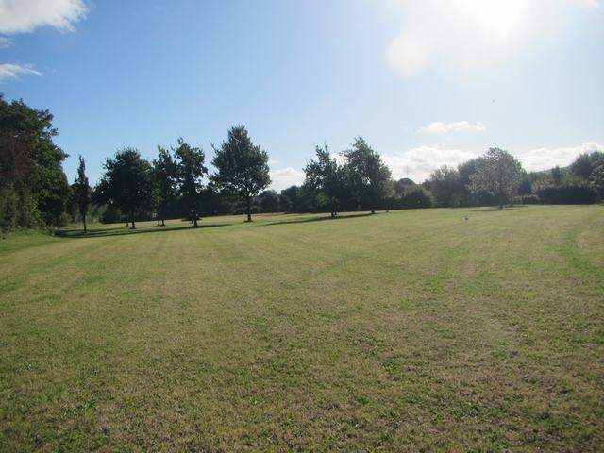

Photograph 13-1: Northern extent of the Proposed Development Site and tree-lined path, looking east
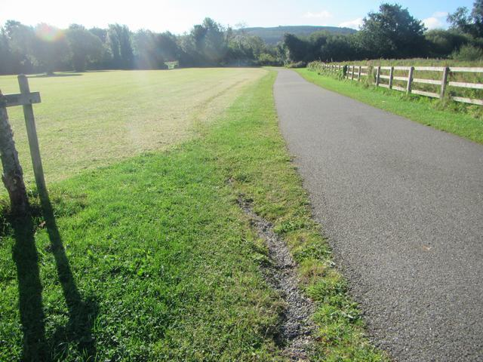
Photograph 13- 2: Ground disturbance adjacent to sports pitch, looking south

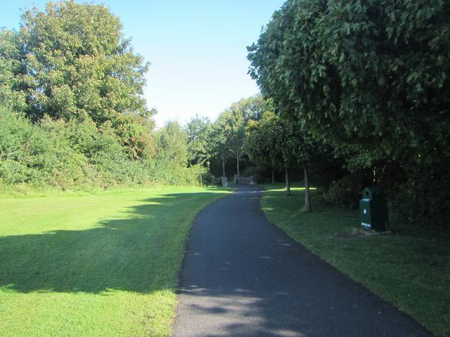
Photograph 13-4: Northeastern boundary of the Site marked by stone bridge, looking northeast
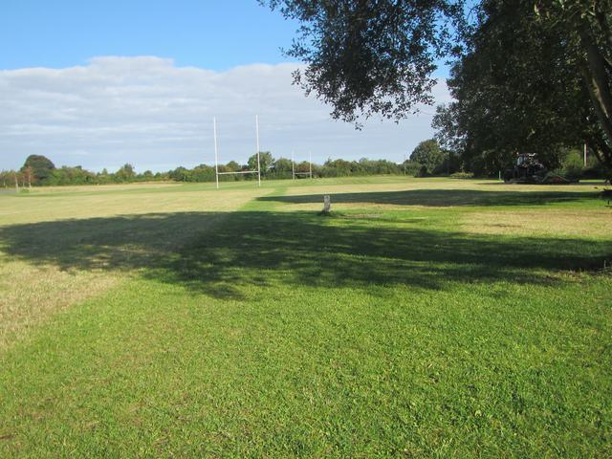
Photograph 13-3: Evidence of utilities installation adjacent to sports pitch, looking north
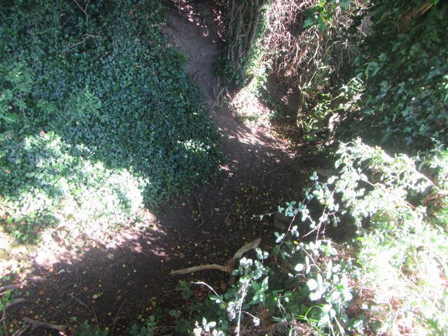
Photograph 13-5: Possible dried-up stream bed forming northern boundary, looking north
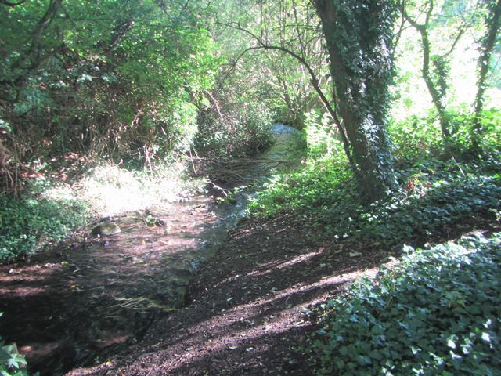
Photograph 13-6: Southern boundary marked by the Cromac River, looking east

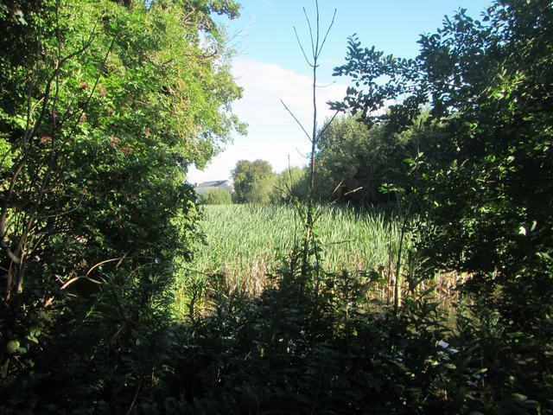
Photograph 13-7: Former Mill Pond (RPS 332), looking east
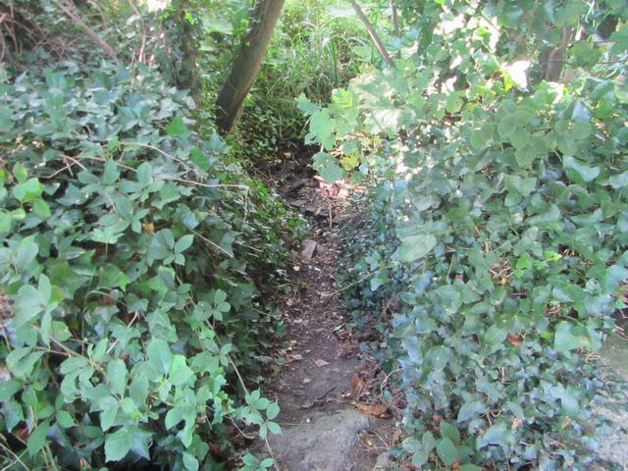
Photograph 13-8: Former Mill Race (RPS 332), looking southwest

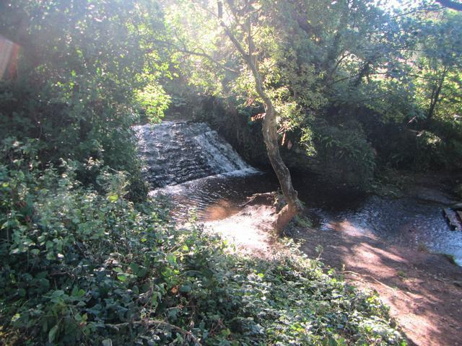
Photograph 13-9: Possible weir adjacent to Mill Race (RPS 332), looking southwest
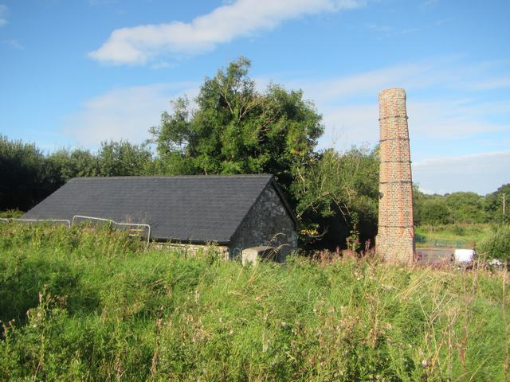
Photograph 13-10: Former Paper Mill (RPS 330), looking north
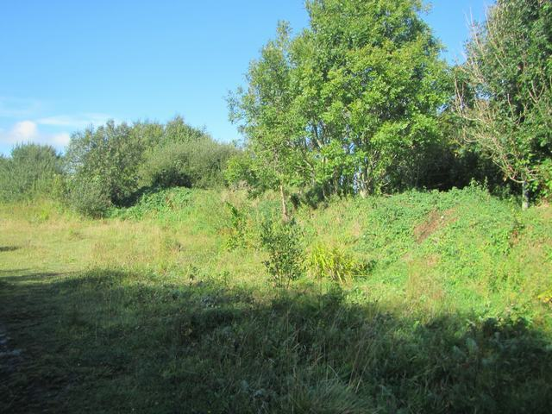
Photograph 13-11: Small earthen bank to the north of the southern boundary, looking northwest
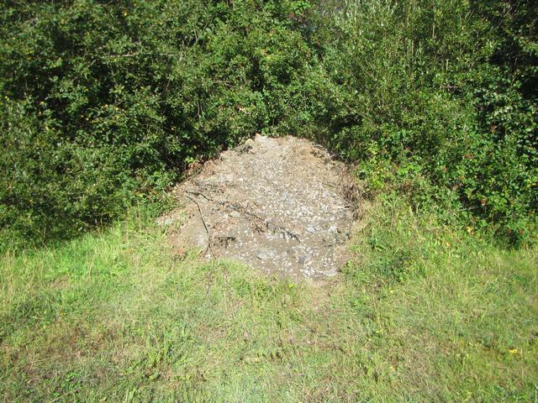
Photograph 13-12: Deposit of spoil material along earthen bank, looking north
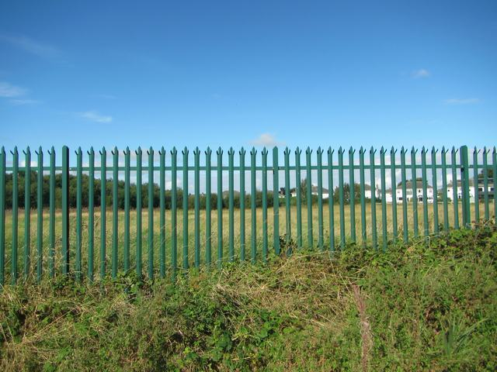
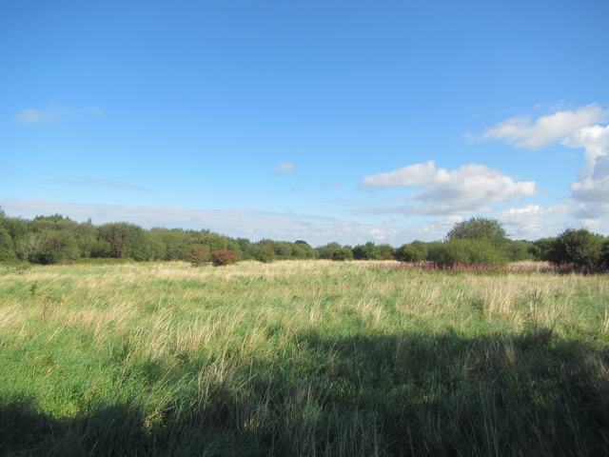
Photograph 13-13: Location of Cropmark (CH1), looking northeast
Photograph 13-14: Northwestern extent of site behind green fencing, looking north
Photograph 13-15: Northwestern extent of the Proposed Development site, looking west
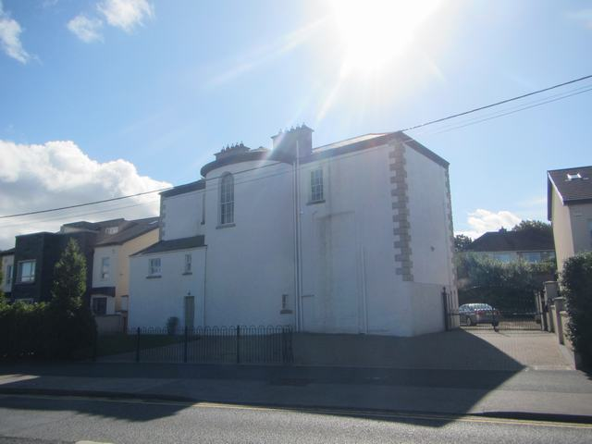
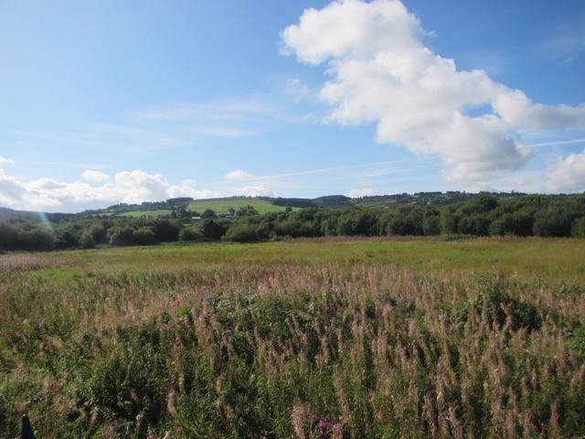
Photograph 13-16: Rathcoole House (RPS 305), looking south
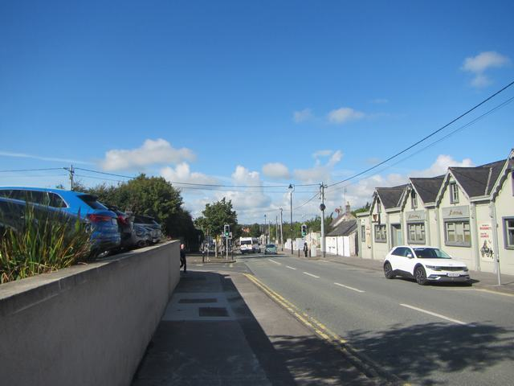
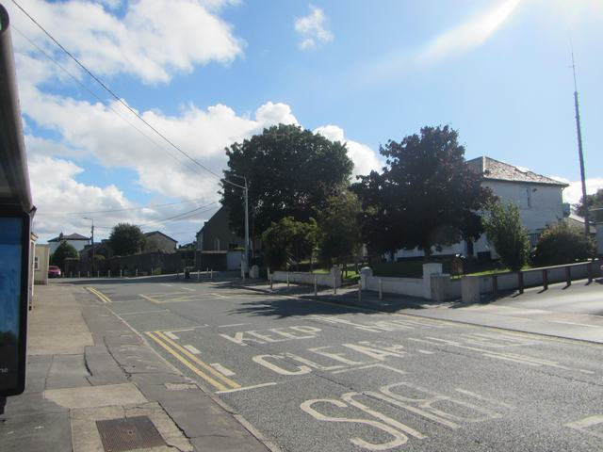
Photograph 13-18: Main Street looking towards the historic core of Rathcoole, looking west
Photograph 13-17: Rathcoole Main Street including Rathcoole Church of Ireland Church (RPS 310) and Rathcoole Garda Station (RPS 311), looking southeast

