
Easy Read Version
South Dublin County Council (SDCC) Disability Advisory Board
In this easy read booklet, we explain what the Disability Advisory Board is and how you can apply to join.
What is the Disability Advisory Board?  The Board gives advice to South Dublin County Council.  The Board:  - Shares ideas  - Gives feedback  - Helps improve Council services | 
Who can apply?  You can apply if you:  - Live in South Dublin County  or  - Work here (paid or voluntary)  or  - Study here  And  - You have experience of disability (your own lived experience)  or  - You work in disability services  And  - You can join the Board for 3 years.  - You care about making South Dublin more accessible |       
What does disability mean?  Disability can include:  - Physical disability  - Mental health disability  - Intellectual disability  - Sensory disability |   
Meetings  - The Board meets 4 times a year.  - There may be extra meetings sometimes.  - Meetings are:  - In person  - Online (Microsoft Teams) | 
Payment  If you do not get a public salary:  - You will get €200 per meeting.  - This money is taxable.  - You manage your own tax.  - You can say no to the payment. | 
Support  If you need support to take part:  - We will provide reasonable accommodations.  - You can tell us your access needs. | 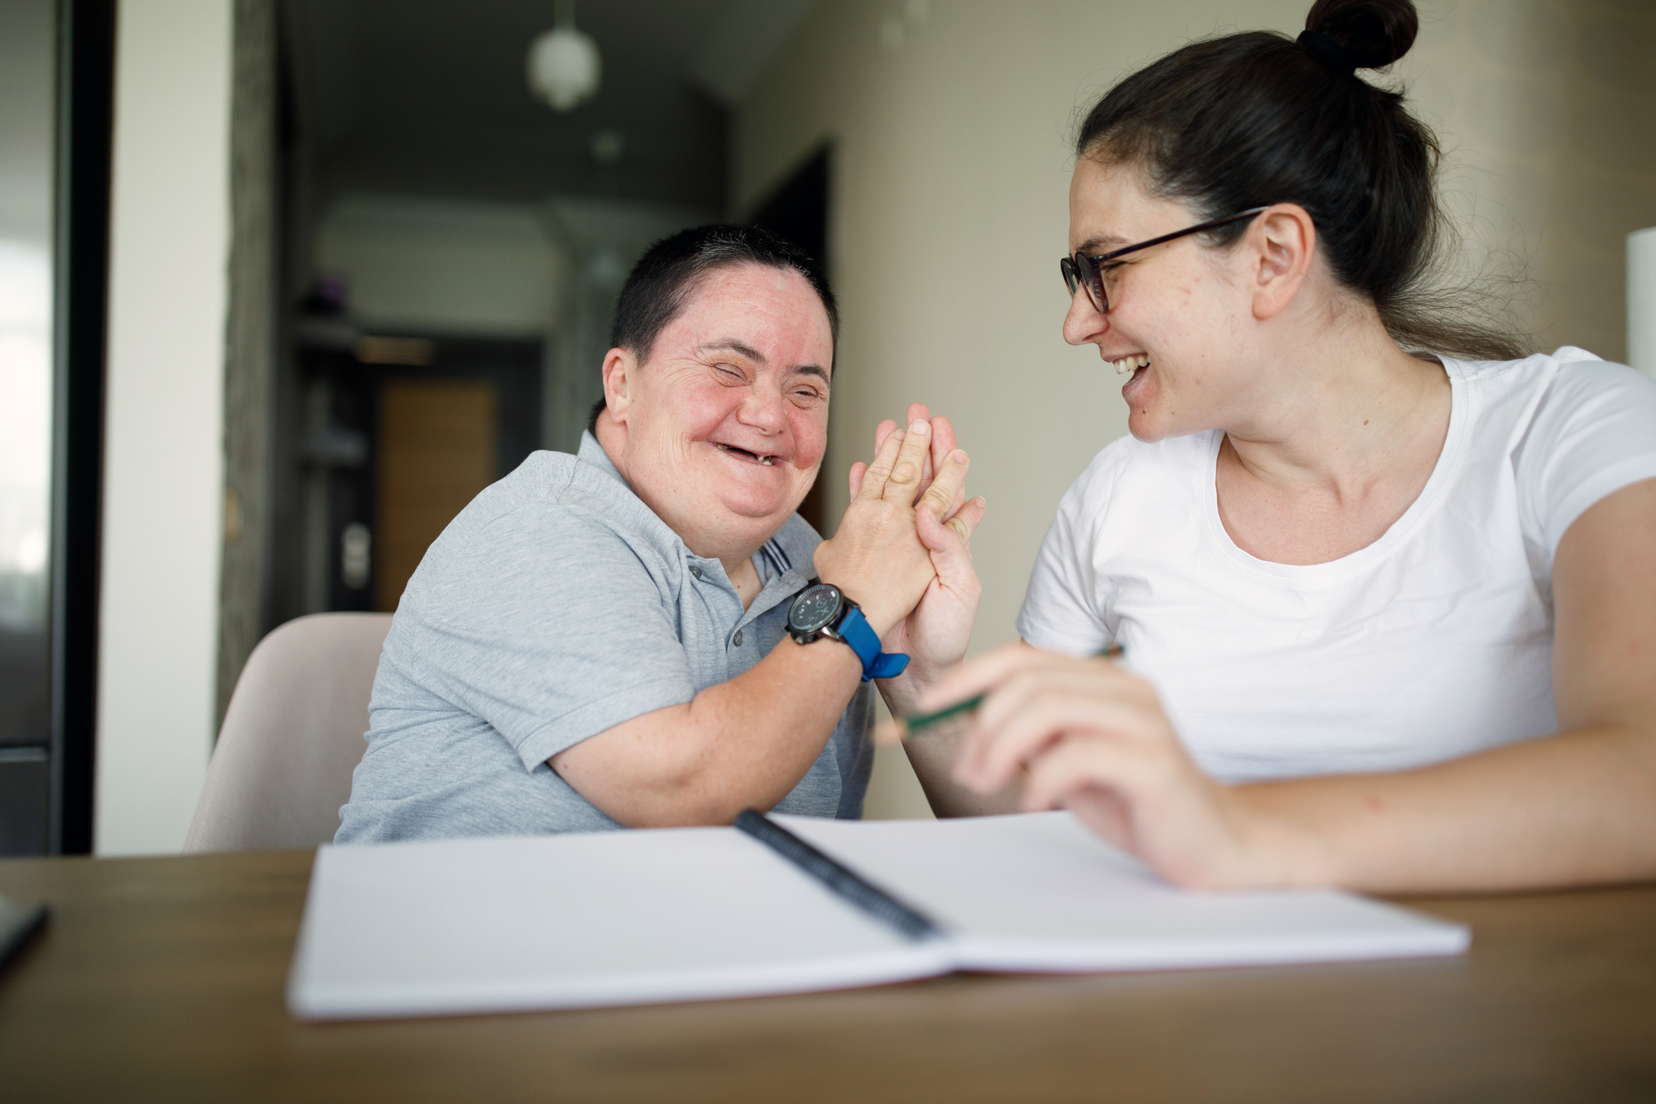
What Board members must do  Board members must believe in:  - Respect  - Equality  - Inclusion  - Accessibility  - Non-discrimination  - Equal rights for women and men  - Respect for children with disabilities  - Respect for independence and choice |   
How to apply  - Answer the questions below.  - Email your form to:  gmeehan@sdublincoco.ie  You can reply in:  - English  - Irish  - Irish Sign Language  And  - Written format  - Video  - Audio  If you need help or another format, email gmeehan@sdublincoco.ie. |       
What happens next?  - SDCC staff will read the applications.  - Some people will be invited to an informal meeting.  - The meeting can be in person or online.  - You can ask for support for the meeting.  - We will tell you if you are a member or not after the meeting. |   
Your information  Your application will be private.  If you are not selected, your personal information will be deleted after the process ends.  By applying, you agree that SDCC can use your information for this application. | 

Application Form
Your Details
Full Name:
Email:
Phone Number:

Questions
1. Tell us about your experience of disability (personal or work experience).
2. Why do you want to join the Board?
3. Can you attend meetings during the year?
4. Can you join for 3 years?
5. Do you live, work, or study in South Dublin County?
6. Is there anything else you want to tell us?

Send your form
Email: gmeehan@sdublincoco.ie
Post:
Grainne Meehan
Access Officer
Corporate Services
Community Department
County Hall
Tallaght
Dublin 24

