

Traveller Choice Based Letting Initiative

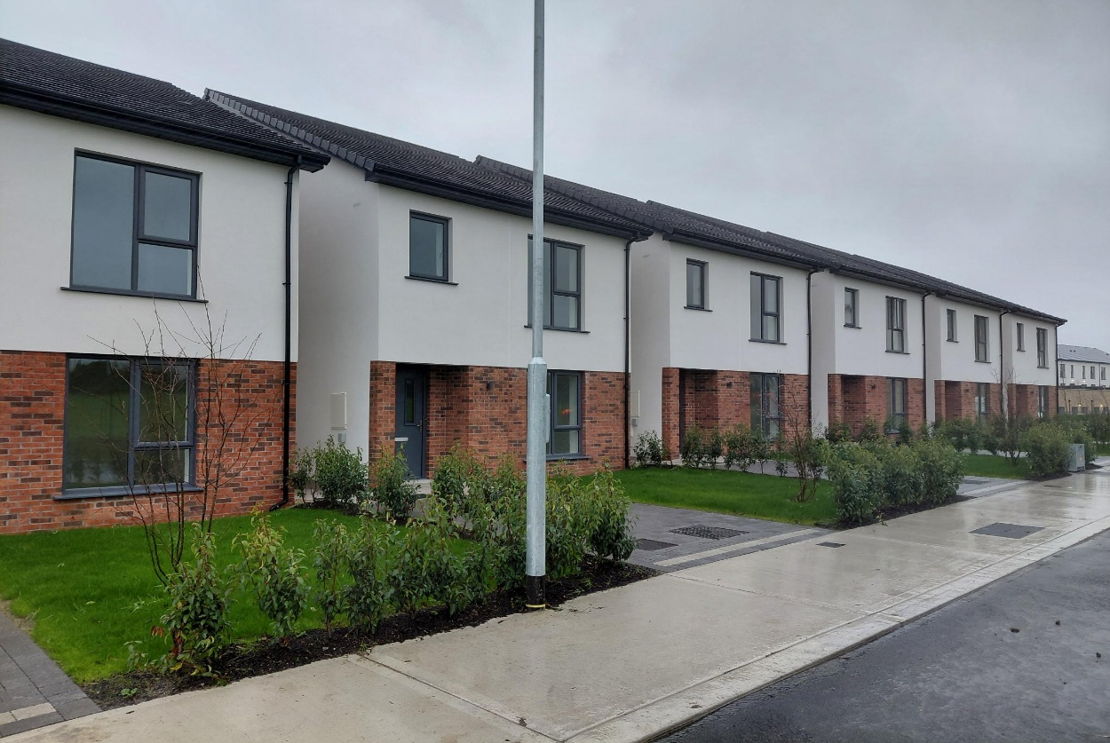
Choice Based Letting for new Traveller
Accommodation Group Housing Scheme 1 – 5, Graydon Rise, Newcastle, Co. Dublin
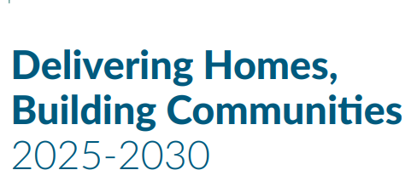
South Dublin County Council is seeking expressions of interest from members of the Traveller Community for a new innovative group housing development comprising five four bedroom, two- storey family homes providing long-term accommodation for Travellers. The homes are built to a high-quality design with A- rated energy efficiency features including air sourced heat pumps. The accommodation comprises of a living room, kitchen with fitted units, dining area, utility room, downstairs toilet with four bedrooms and a bathroom on the first floor. Located in a residential area in Newecastle within reach of local shops, parks, schools, recreational facilities and transport links.

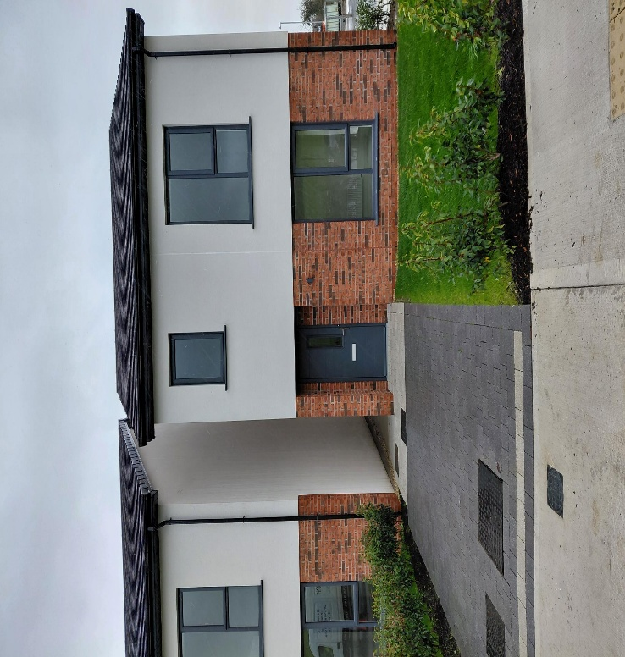

Scheme of Priority Applications for these new homes will be assessed in accordance with the Scheme of Priority below:

Priority 1 - Tenants / Licensees whose existing homes are due to be demolished or refurbished to build new council homes. Please note that Tenants / Licensees who have already moved as part of an estate refurbishment / renewal scheme will not be eligible to apply.
Priority 2 – Tenants / Licensees living in long term homeless with a four-bed requirement to meet their family need in accordance with the Council’s Allocation Scheme for Traveller specific / standard social housing.
Priority 3 – Tenants / Licensee currently living in a Traveller specific accommodation within South Dublin County Council’s administrative area: a) Tenants / Licensees who are currently over-crowded in order of the net number of additional bedrooms they require, and then by their place on the housing transfer list. Tenants will not be permitted to bid for homes larger than their assessed housing need unless there are exceptional circumstances. b) Tenants / Licensees in order of their place on the housing transfer list. c) Other Tenants / Licensees who are adequately housed, in order of their tenancy start date.
Priority 4 – All other applicants who have identified as an Irish Traveller in their application form for Social Housing Support: a) Any remaining properties will be let in accordance with the Council’s Allocation Scheme for Traveller specific / standard social housing
Criteria:
Tenants / Licensees in Priority Group 1 and 3 will be eligible to apply for this development where they meet the following criteria: · The Tenant / Licensees must hold a secure tenancy / licence agreement (in their own name / names), with South Dublin County Council. · The Tenant / Licensees must have lived at their current address for at least 24 months prior to 13/03/2025.
The Tenants / Licensees will be required to hand back the keys and give vacant possession of their existing home / bay on taking up an offer of a new home in the development.
All applications will be considered on estate management grounds, and the Tenant / Licensees must not have caused anti-social behaviour or committed any other tenancy breach in the last 12 months or where a Notice to Quit, or legal action is being taken by the council. · Tenants / Licensees will only be allowed to apply if they have a clear rent account, unless there are exceptional circumstances.

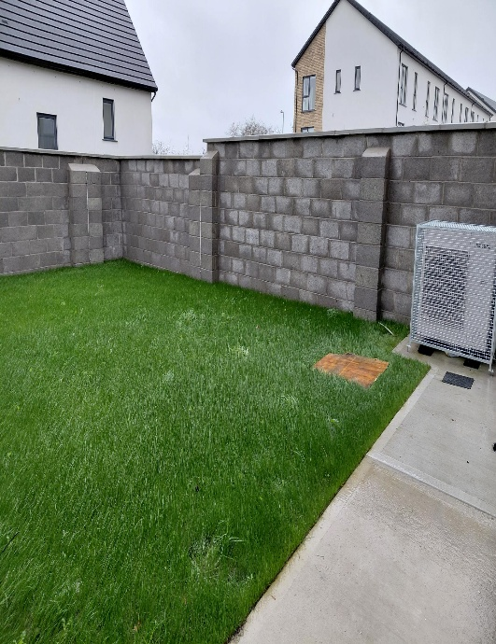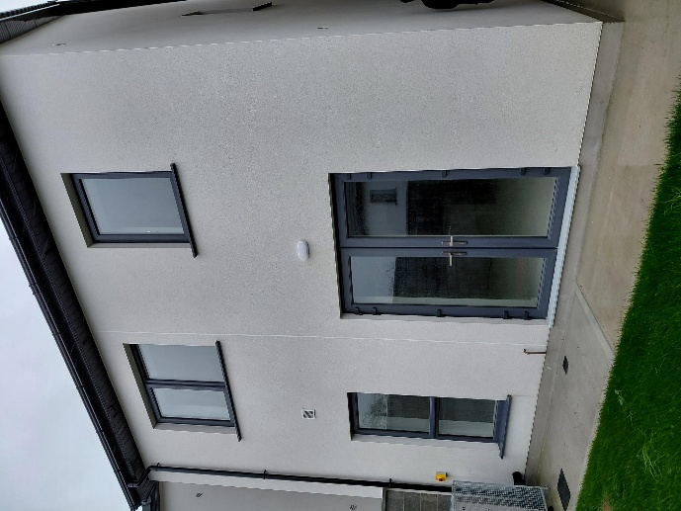
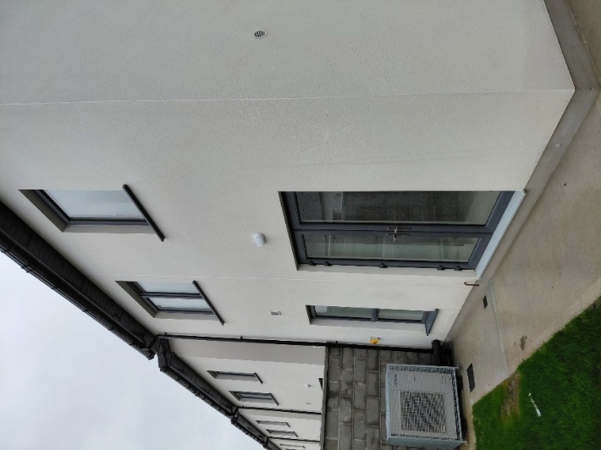
Floor Plans
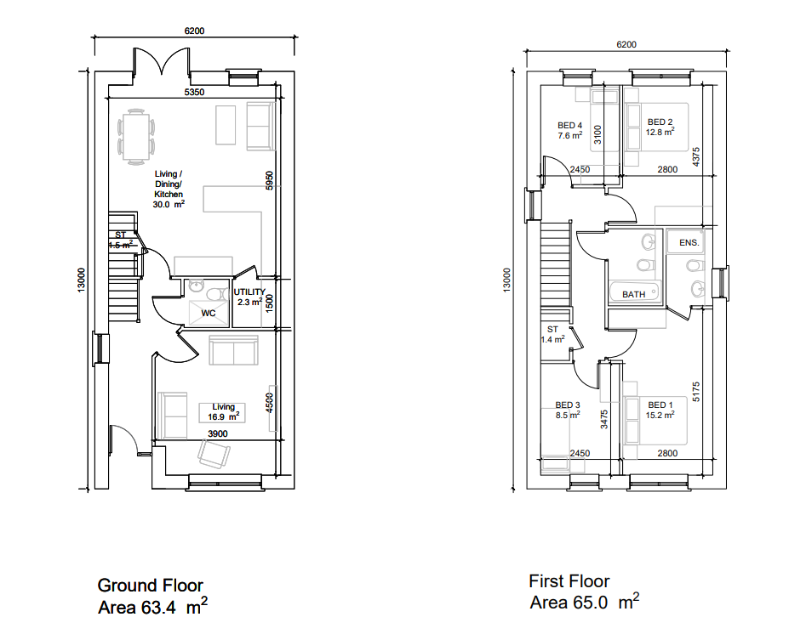
Site Plan
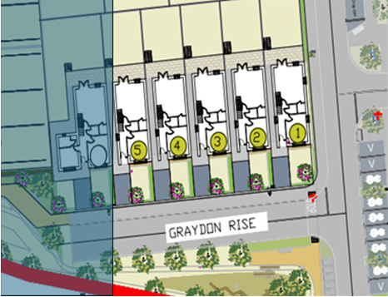
Graydon Rise
Expression of Interest – Application Form
Closing date for Applications is Friday, 20th March 2026
Name of Applicant(s): _________________________________________
Phone No: __________________________________________________
Present Address: _____________________________________________
Are an existing Tenant/Licence holder: YES/NO Date of Tenancy/Licence Agreement: _________________________________________________
Rent Account Number: _________________________________________
Are you currently on South Dublin County Council’s Housing List: YES/NO
Housing Application Reference Number: ___________________________
PPS number (s):______________________________________________
Email address: _______________________________________________
PARTICULARS OF APPLICANT(S) AND FAMILY (TO BE COMPLETED IN FULL).
Please list details of additional family members on blank sheet provided.
Members of household | Sex (Male/ Female) | PPS Number | Date of birth | Occupation | Name/Address of Employer/School | Income
*Please note this application cannot be processed without PPS Numbers for all members of the household.
Have you/your partner previously made an application for a transfer?
Weekly Rent: €________ No. of bedrooms: ________
Condition of dwelling: ________________
Have you/spouse/partner previously had a tenancy with any Local Authority: YES/NO
IF YES, please state:
Name of Authority | Address of dwelling | Dates of Tenancy  (From – to)

Reason for requesting transfer: (relocation, overcrowding, anti-social)
Collection and Use of Personal Data Collection and Use of Personal Data ALL data supplied by you when completing this form (including any personal data you submit) will be used for the purposes of assessing and administering your application for Social Housing Support. The law allows this local authority in certain circumstances to share your data with other public bodies. For example, we may share your data with the Central Statistics Office under the Statistics Act 1993. The data supplied by you when completing this application may be shared with the Local Government Management Agency (LGMA) and The Housing Agency in order to fulfil a statutory requirement to provide an annual Summary of Social Housing Assessments, including the production at a national level of statistical reports that inform policy and future planning in terms of the national housing need. In carrying out its functions under the Housing Acts of 1966-2014, the local authority may request and obtain information from other organisations. These include another local authority, the Criminal Assets Bureau, An Garda Síochána, the Department of Social Protection, the Health Service Executive (HSE), the Revenue Commissioners or an Approved Housing Body in relation to current or prospective occupants of, or applicants for, local authority housing. Your data may also be shared with other public bodies in accordance with our obligation to prevent and detect fraud.



