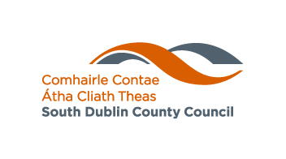
Rebuilding Ireland Home Loan

SDCC CHECKLIST FOR APPLICANTS

Applicants are strongly advised to submit their applications in person at this office as posted applications frequently are not completed correctly and have to be returned.

- Fully Completed Application Form

- Letter from two Banks or Building Societies confirming insufficient offers of
Finance. (Actual amount applied for must be specified)
- HPL1 Form to be stamped by Revenue Commissioner (Appendix 1A)
please see note HPL1 form requirement during COVID-19

For applicants born outside the Republic of Ireland, please submit proof that
you do not currently own or have never been the registered owners of land or
property in your country of origin. We will require original certified documents
(translated into English) from your country of origin.

- Photographic Identification (Current Passport or Drivers Licence)

- Proof of Present Address (Current Utility Bill or Bank Statement)
- Original Salary Certificate signed and stamped by employer (Appendix 1)

- Up-to-date, computer generated P60 and P21 and 4 recent payslips

- Signed Customer Declarations
- Original Current Account Statements (12 Months)
- Original Savings Statements (12 Months)
- Original Loan Statements (12 Months)

- Original Credit Card Statements (12 Months)

- Original Credit Union Statements (12 Months)

Self Employed

- Accountants Report/Audited Accounts (2 Years Required)
- Current Tax Balancing Statement
- Current Preliminary Revenue Tax Payment Receipt

For Those Renting
- Tenants in private rented accommodation must have a clear rent account
for 6 months prior to applying, and be able to show a rent book or proof of
payment.

- Tenants of a local authority or tenants under the RAS scheme must submit a letter from the Rent Assessment Section confirming that their rent assessment is up to date and the account is clear for 6 months prior to applying.

Applicants in Receipt of Unemployment/ Social Welfare Benefits
- Appendix 2 completed by the Department of Employment Affairs and Social Protection

- Statement of total benefit received in the preceding year.

South Dublin County Council require applicants to have sufficient funds in reserve to cover legal fees and costings associated with purchasing a property.

