Give our thirsty trees a drink
With ongoing hot and dry weather South Dublin County Council is asking local residents to help look after South Dublin’s street trees especially those recently planted.
The Council are watering these newly planted trees but our trees would benefit from an extra drink where possible.
While we are doing our best to ensure our trees remain healthy, any help from the community in terms of watering is always appreciated and very beneficial, especially during the hot and dry conditions.
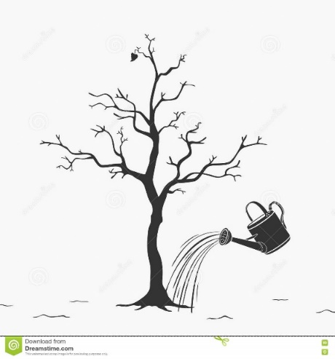
Tree Watering Tips
- The water should be applied slowly under the tree canopy close to the trunk. We especially ask people to look for stressed or struggling trees. There are a few signs that your neighbourhood trees are in trouble including sparse leaf cover, dead branches in the canopy, also curling, browning or drooping leaves. In terms of priority you should water trees less than five years old. We need to give our younger trees the best possible chance of survival.
- Water the base of the tree at least twice per week. Water during cooler times of the day for example before 9am and after 8pm. Water slowly to soak deep into the ground to reach the roots. Water even if it rains. The small amount of rain we get during dry seasons is not enough for our street trees.
- Using grey water: Second class water such as shower or bath water is suitable for watering plants, (no leftover food in the water).
- Rain Barrels: Purchase a rain barrel to start conserving water and saving money.
Thanks for keeping our urban forest healthy and lush!

