Application for European Action Week Against Racism Competition 2021
To mark European Action Week Against Racism 2021 the Social Inclusion Unit are hosting a competition. This competition aims to create awareness of racism and celebrate cultural diversity of people living in South Dublin today.
Name

Address

Category: Adult / Child

Child's age
Contact Number / Guardians Contact Number

Guardians name

Name and Address of School

Email

Title of Entry
Anybody can take part in this competition by conveying the message "Racism has no place in South Dublin". Enter through any of the following:

Poetry, prose, art, photography….. (Maximum: Poetry 30 lines, Prose: 750 words)

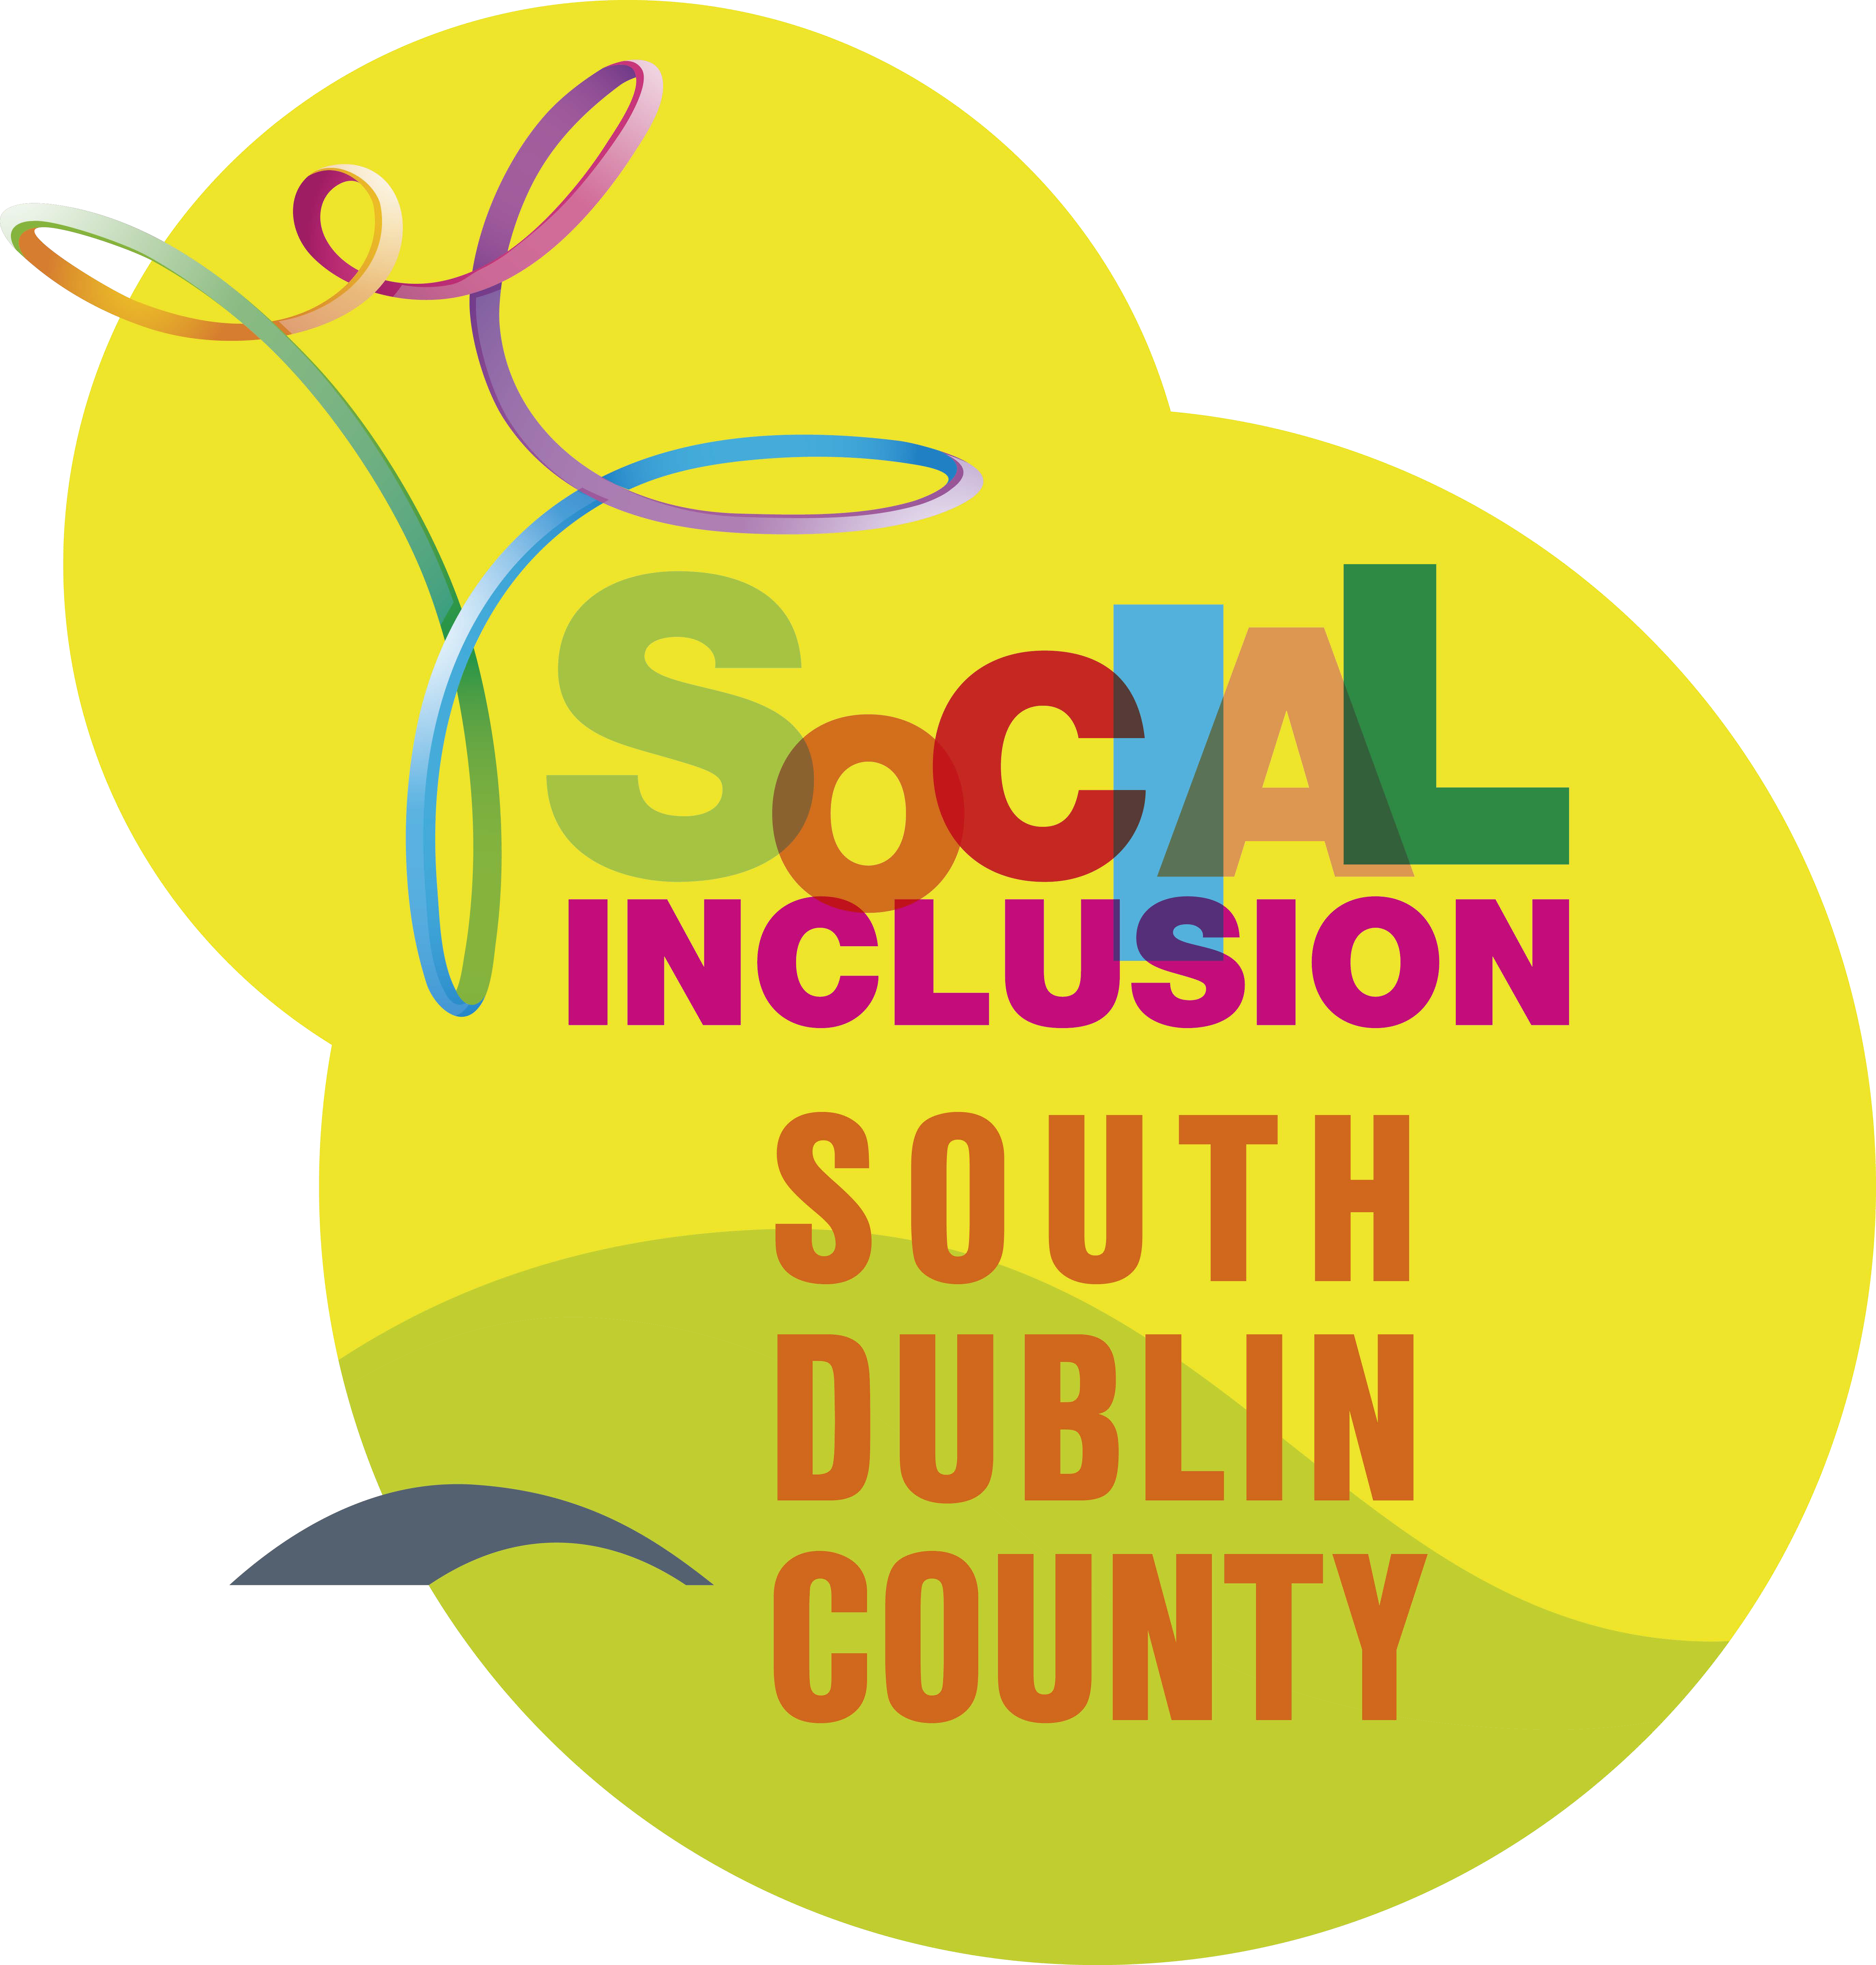
Prizes in the form of Vouchers to be won!
Please return entry by email to:
socialinclusionunit@sdublincoco.ie

By Friday 2nd April 2021

Please confirm you have read and agreed with the Privacy Statement attached by signing below. If this form is not signed and application form is not fully completed, your application will not be accepted. Electronic signatures are also accepted.

Signature

Comhairle Contae Átha Cliath Theas, Halla an Contae, Tamhlacht,
Átha Cliath 24.

South Dublin County Council, County Hall, Tallaght, Dublin 24.

Tel: +353 1 414 9270
Email: socialinclusionunit@sdublincoco.ie

Ceangail 24/7 Connect 24/7 with Council information and services at www.southdublin.ie

