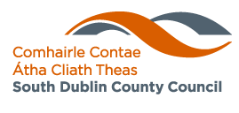

Corporate Procurement Plan 2024 - 2026

Contents

1 Mission 3
2 Introduction 3
3 Delivery of policy actions 2021 - 2023 5
3.1 Procurement thresholds and procedures 5
3.2 Key figures 6
3.3 Project snapshots 8
3.3.1 Beechfield Park 8
3.3.2 New Artificial Grass Pitch at Sean Walsh Park 9
3.4 Supplier engagement 10
3.5 Green Public Precurement 10
4 Specific goals and targets 2024 - 2026 12
4.1 Governance 12
4.2 Procurement planning and achieving efficiencies 14
4.3 Compliance with procurement rules and requirements 16
4.4 Value for money on cost and contract performance 17
4.5 Business engagement measures 18
4.6 Sustainable procurement measures 20
4.7 Innovation and diversity measures 20
5 Measurement and monitoring of implementation 21
Appendix A: Measurement and monitoring of the implementation of South Dublin County Council’s Procurement Plan 2021 - 2023 22

Mission
To make our county a vibrant and inclusive place for the people who live, visit, work, and do business here, now and for the future.

South Dublin County Council Corporate Plan 2020 - 2024

Introduction
The Corporate Procurement Plan is South Dublin Conty Council’s three-year strategy to form the basis for strong management, risk management, audit and corporate governance systems for procurement by the Council. The Corporate Procurement Plan 2024 - 2026 builds upon the work commenced in the Corporate Procurement Plan 2021 - 2023. It sets out the Councils key corporate procurement objectives and goals over the next three years.

Public Procurement can be defined as the acquisition, whether under formal contract or not, of works, supplies and services by public bodies. It ranges from the purchase of routine supplies or services to placing contracts for large infrastructural projects. South Dublin County Council procurements are governed by EU and national rules and objectives, including the principles of the Treaty on the Functioning of the European Union, namely transparency, mutual recognition, equal treatment of tenderers, non-discrimination and proportionality.

The Corporate Procurement Plan 2024 - 2026 outlines our key procurement objectives and goals over the next three years. As detailed in South Dublin County Council’s Corporate Plan 2020 - 2024 councilors and staff of South Dublin County Council will be guided by six core values:

- Customer service
- Sustainability
- Inclusiveness, equality and accessibility
- Innovation, creativity and diversity
- Accountability and transparency
- Value for money

We have identified our specific procurement goals and targets for 2024 - 2026 in keeping with the ‘Guidance for Corporate Procurement Planning in the Local Government Sector’ (Local Government Strategic Procurement Centre, 2015) and the ‘Corporate Procurement Plan Information Note’ (Office of Government Procurement, 2019).

As noted in the Corporate Plan 2020 - 2024 (page 17) “the economic future is uncertain – particularly due to Brexit and growing uncertainties about international trade. This means we must maintain a focus on building competitiveness and managing our finances sustainably”. These factors are reflected in the Corporate Procurement Plan 2024 - 2026.

The Plan has been prepared in consultation with the Procurement Steering Group and Senior Management and has been approved by the Chief Executive. The Plan is divided into four sections. An overview of the work carried out over the last three years is detailed in Section 3 Delivery of policy 2021 - 2023 and Appendix A: Measurement and monitoring of the implementation of South Dublin County Council’s Procurement Plan 2021 - 2023. Our Specific goals and targets 2024 - 2026 are detailed in Section 4, and the approach for the implementation is outlined in Section 5. Each year we will assess our progress on achieving our identified goals and targets, and we will prepare and publish an annual monitoring and implementation report.

Delivery of policy actions 2021 - 2023
The Corporate Procurement Plan 2021 - 2023 focused on embedding and supporting the application of good procurement practice in South Dublin County Council. Over the lifetime of the plan many initiatives also took place to support businesses and to include sustainable procurement measures in tenders. The actions in the plan were divided into seven key areas:

- Governance;
- Procurement planning;
- Compliance with procurement rules and requirements;
- Value for money on cost and contract performance;
- eProcurement;
- Business engagement measures; and
- Sustainable Procurement.

A review of the current organisational position for each of these areas was carried out for the preparation of this plan, as was an analysis of the activity carried out over the life of the Plan. As part of the Plan a report to measure and monitor the implementation was prepared annually. It is available in Appendix A and on the internet at www.sdcc.ie/en/services/business/procurement. The Public Spending Code Quality Assurance Report is also prepared annually and is available on our website.

Procurement thresholds and procedures
South Dublin County Council’s current procurement procedures governing how procurements are advertised are outlined in Figure 1. With effect from 1st January 2024, all contracts over the value of €221,000 for supplies / services and over €5,538,000 for works are subject to European Procurement Directives and must be advertised in the Supplement to the Official Journal of the European Union (OJEU) and on the Irish government procurement portal www.etenders.gov.ie. Contracts below these thresholds are not subject to European Procurement Directives. Purchases above the value of €50,000 for supplies / services and over €200,000 for works are advertised on www.etenders.gov.ie. The procurement procedures in South Dublin County Council for various procurement values are summarised in Figure 1.
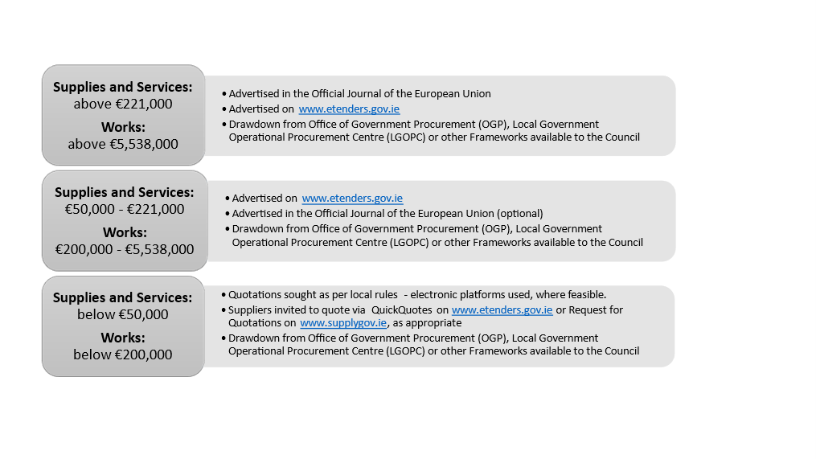
Figure 1 Summary of procurement procedures in South Dublin County Council for various procurement values.

Key figures
The dedicated procurement team in South Dublin continued to support the Council’s service departments manage tender processes in line with the procurement rules and regulations from 2021 - 2023. A summary of the tender and quotations competitions advertised by South Dublin County Council over the three years are available in Figure 2. The Council advertised competitions directly, used central purchasing arrangements, such as those established by the Office of Government Procurement and the Local Government Operational Procurement Centre, as well as quotations to source the supplies, services and works required to deliver Council services in the County.

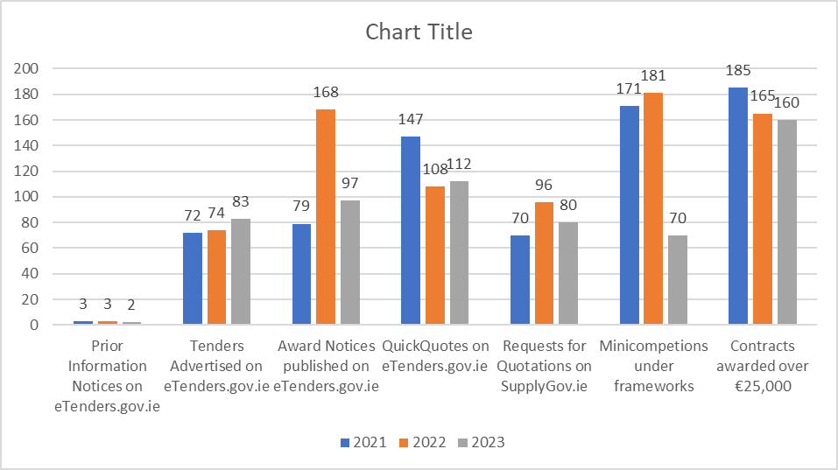
Figure 2 Overview of tendering and quotations activity 2021 - 2023

Project snapshots
A wide range of supplies, services and works were tendered between 2021 and 2023. A small selection of these are outlined below.

3.3.1 Beechfield Park – Anyone for Tennis!

South Dublin County Council completed the full refurbishment of the six tennis courts and installed 1 new 3x3 basketball half-court at Beechfield Park. The upgrade has provided 6 tennis courts to International Tennis Federation standards and one 3x3 basketball half-court which has been built to International Basketball Federation standards.

The works in the tennis courts included completely resurfacing the playing area, new line markings, new posts, new nets, and improvements to the boundary. These works have been funded through the Sprots Capital Grant and the Public Realm Revenue budget.

The aim of the court upgrades is to empower people to create healthy habits, allowing people to improve their own physical and mental well-being through exercise in a public park.

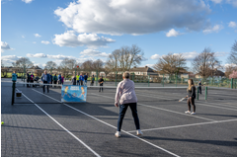

3.3.2 New Artificial Grass Pitch at Sean Walsh Park, Tallaght.

The 3G Artificial Grass Pitch at Sean Walsh Park, Tallaght was completed in 2023. The opening of this pitch in Tallaght marked the delivery of the first pitch of the Councils 3G Artificial Grass Pitch Programme.

Sean Walsh 3G Artificial Grass Pitch was funded by South Dublin County Council and an Urban Form Development framework grant via the national Planning Framework and the department of Housing, Local Government and Heritage. The pitch booking fee is competitively priced to support Local teams and community and to facilitate and increase in active recreational use.

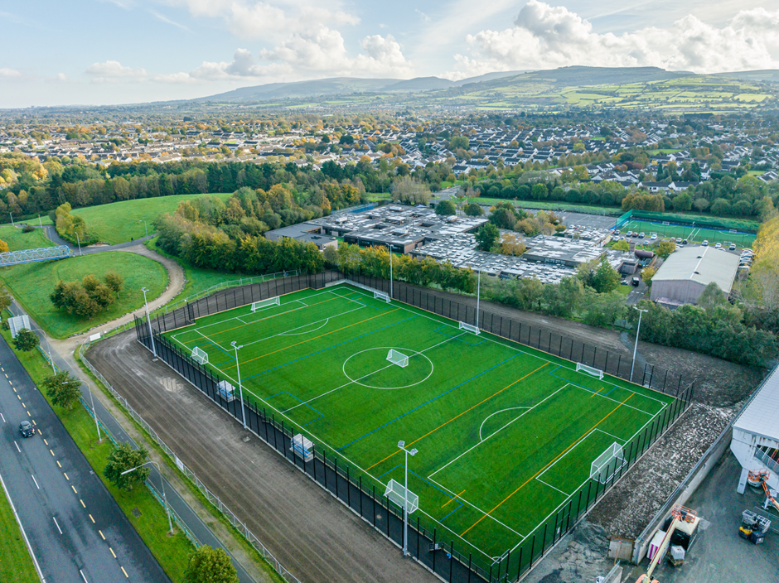

Supplier engagement
To ensure that we regularly engage with suppliers and businesses to support them through the procurement process, while ensuring we meet our obligations to assist SME’s in Public Procurement

- The Procurement Unit has worked closely with the Local Enterprise Office to create a Bi-lingual information leaflet to ensure local businesses wishing to do business with South Dublin County Council are aware of the processes in place;

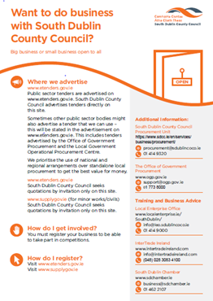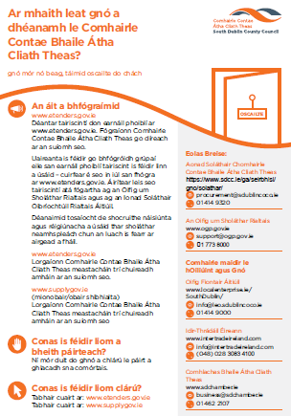

Bi-lingual information leaflet – Want to do business with South Dublin County Council?

- The Procurement Unit will continue to engage with business and interested suppliers through participation in and attendance at Meet the Buyer conferences and other business engagement opportunities that arise;

- The Procurement Unit will provide a support for businesses interested in registering as suppliers on eTenders and provide an advisory service for supplier questions, outside of the tender processes run by buyer departments.

Green Public Procurement

Green Public Procurement Strategy and action plan

Following a government decision to review Green Tenders, the Department of the Environment, Climate and Communications (DECC), as the lead Government department in developing Ireland’s Green Public Procurement policy, is publishing a new Green Public Procurement Strategy and Action Plan which will cover the period 2023 - 2027. Preparation of a new Green Public Procurement Strategy and Action Plan is also commitment in the Climate Action Plan 2023.

The key objectives of this Green Public Procurement Strategy are to:

- Enhance Green Public Procurement as a key tool for the Public Sector in helping Ireland’s transition to a sustainable, circular and low carbon economy;
- Ensure Green Public Procurement is a core and integral component of the public procurement process and associated governance structures in Ireland;
- Set out measures to ensure that all procurement using public funds include green
criteria, where possible;
- Support further development of Green Public Procurement criteria, enhance Green Public Procurement knowledge and expertise and facilitate Ireland’s participation in international collective efforts to use GPP as a lever for sustainable production and consumption; and
- Support market conditions needed to deliver sustainable and innovative solutions for
Green Public Procurement.

Underpinning this Green Public Procurement Strategy and Action Plan is an acute awareness that the systematic deployment of Green Public Procurement criteria across the public sector can contribute in a meaningful way to the achievement of Ireland’s climate and energy efficiency targets, in addition to contributing to sustainability at a more global level.

Ireland’s Climate Action Plan sets out the commitment for the public sector to play a leadership role in driving far-reaching climate action across its buildings, transport, waste, and energy usage.

An ability to adjust to these changes will also be a part of the 2024 - 2026 Corporate Procurement Plan.

Specific goals and targets 2024 - 2026
The Corporate Procurement Plan 2024 - 2026 will build upon the established structures and processes to ensure the application of good procurement practice, the realisation of efficiencies, and compliance with the procurement directives and regulations throughout the organisation. The following specific goals and targets have been identified and can be divided into seven key areas:

- Governance;
- Procurement planning and achieving efficiencies;
- Compliance with procurement rules and requirements;
- Value for money on cost and contract performance;
- Business engagement measures;
- Sustainable procurement measures; and
- Innovation and diversity measures.

Specific actions under each of these areas are detailed below.

Governance
- The Corporate Procurement Steering Group will meet quarterly to oversee the implementation of the Corporate Procurement Plan.

- A revised Chief Executive Order outlining the procurement rules and procedures for the different expenditure thresholds will be put in place, reaffirming the Council’s commitment to the application of good procurement practice. The Order will also approve the Corporate Procurement Plan 2024 - 2026.

- The dedicated Procurement Officer and Procurement Unit will be retained and will continue to support purchasing staff in the application of good procurement practices in the Council.

- An annual report on the Measurement and Monitoring of the Implementation of the Corporate Procurement Plan will continue to be prepared and published by the Procurement Unit.

- Summary details of contracts awarded valued at over €25,000 will continue to be published by the Procurement Unit on our website as part of our Freedom of Information Publication Scheme.

- To continue to oversee best practice in procurement activity the following advertising methods will be issued solely from the Procurement Unit:
- All South Dublin County Council run tender competitions above national and EU thresholds advertised on www.etenders.gov.ie
- All mini-competitions from South Dublin County Council frameworks, other Local Authority frameworks available to the Council, or national frameworks available to the Council (for example, National Transport Authority, Department of Justice). Mini-competitions will be run through www.etenders.gov.ie, where feasible.
- Quotations sought through QuickQuotes

Mini-competitions from OGP frameworks may be routed either through the Procurement Unit or the purchasing Department may liaise directly with the OGP and notify the Procurement Unit of the planned procurement competition.

All mini-competitions from Local Government Operational Procurement Centre (LGOPC) frameworks and dynamic purchasing systems advertised through www.supplygov.ie will continue to be administered locally in the purchasing Department.

- For competitions above the EU thresholds outcome letters will continue to be issued through www.etenders.gov.ie and copies of Article 84 reports will be filed by the Tender Manager with the Procurement Unit.
- Procurement objectives from the Corporate Procurement Plan will continue to be incorporated into the Performance Development Management System, as actions in Team Development and Personal Development Plans.

- The Council will prepare and publish an annual Public Spending Code Quality Assurance Report in line with national circulars. The Council will provide training for relevant staff on the requirement of the Public Spending Code, to support compliance with the Code. Project managers will carry out appropriate project appraisals throughout the lifecycle of the project in keeping with the requirements of the Code.

Procurement planning and achieving efficiencies
- A procurement pipeline will be prepared by the Procurement Steering Group after the annual budget process and annual service delivery plans, to assist with planning and co-ordinating the procurements required to deliver the Council’s annual service delivery plan.

- All procurement arrangements (such as, contracts / frameworks / dynamic purchasing systems / panels) valued at over €25,000 will be recorded promptly on award on the corporate contracts database by the purchasing Department. All Chief Executive Orders awarding a contract over €25,000 are to note that this contract will on approval be recorded in the corporate contracts database.

- The Procurement Unit will regularly monitor the procurement pipeline and contracts database and will prepare reports for the Procurement Steering Group to consider on items such as opportunities for efficiencies identified.

- The Procurement Unit will support service delivery and business continuity by monitoring and reporting on contracts due for renewal that are nearing expiry to the Procurement Steering Group.

- When carrying out a procurement, purchasers are encouraged to consider procurement approaches that look at requirements on an annual / multi-annual basis, and where applicable to consider additional requirements that may arise over the term of a project. Suitable measures should then be included in the tender documents; for example, including options, establishing framework agreements, use of life cycle costing models and so on.

- Relevant staff will engage with the Office of Government Procurement (OGP), the Local Government Strategic Procurement Centre (LGSPC), Local Government Operational Procurement Centre (LGOPC), the Dublin Regional Procurement Forum and other national networks to maximise opportunities and efficiencies from shared procurements.

- Relevant issues and potential risks to service delivery associated with contracts will be considered and suitable mitigating measures put in place as part of the Council’s Risk Management Processes.

- The Council will use Low Value Purchase (LVP) cards for low value expenditure on supplies where appropriate such as those required on a one-off or emergency basis, to minimise the processing costs for these transactions. The use of LVPs will be governed by appropriate control measures, and the expansion of LVPs across the Council will be subject to audit assurance that existing control measures are enforced and are appropriate.

- The steps in the process in carrying out a procurement will be assessed by the Procurement Unit / Project Managers to identify areas where transactional savings can be realised. This may include combining shared requirements into a single tender / quotations process and considering a low value payments strategy for the Council.

Compliance with procurement rules and requirements
- The Procurement Unit will continue to communicate procurement requirements, including regulations, policies, procedures and so on, in the organisation through the Procurement Steering Group, intranet site, procedures manual, and training programmes.

- The Procurement Unit will provide procurement advice and assistance on request to staff preparing tender documents.

- Standard template documents will be used for seeking tenders.

- A policy and procedure on the Health and Safety aspects of procurement for supplies and services will be prepared. The policy and procedure will be implemented by the Procurement Steering Group. The Health and Safety Officer will advise on the implementation and undertake inspections and audits under this policy and procedure.

- The Procurement Unit will carry out pre-publication checks on a portion of tenders to give assurance of compliance in the Council with procurement rules.

- The procurement functionality in the Financial Management System (“Milestone 7”) will be utilised, to improve reporting on contract spend and compliance with procurement rules.

- Independent assessment of compliance with procurement rules will be carried out by the internal and external audit functions.

- Where personal data is received as part of a competition or processed in the administration of a contract suitable measures will be put in place by the Contract Manager to safeguard the data in line with the requirements of the General Data Protection Regulation (GDPR).

- The Data Retention Policy for Procurement Related Records will be implemented by the Procurement Unit and purchasing Departments. The Council will try not to hold records beyond the necessary timeframes.

Value for money on cost and contract performance
- The Council will continue to prioritise the use of national and regional arrangements over standalone local procurement to ensure that opportunities for efficiencies are maximised.

- Ongoing expenditure analyses will be conducted both at organisational and department levels to monitor items such as suppliers approaching procurement thresholds; measure contract / framework expenditure; identify further areas for corporate contracts and monitoring instances of off-contract spend.

- For contracts which encompass the activities of a number of sections in the Council one Department will take the role of lead purchaser and co-ordinate the preparation of the procurement and will act as contract manager once the contract is in place. This will generally be a function devolved to staff outside of the Procurement Unit. However, on occasion, the Procurement Unit may take the lead in the preparation of tenders for supplies / services required by multiple Departments, subject to availability of resources in the Unit.

- For contracts which encompass the activities of a number of Departments updates on contract performance will be an agenda item for the Procurement Steering Group. If any issues arise, they should be brought to the attention of the supplier in the first instance for swift resolution, and where necessary to the attention of the relevant Contract Manager in the Council for information or action as required.

- The competitive nature of procurement processes, that is, seeking quotes or tenders, to continue to be prioritised as a method of attaining value for money. Award criteria including quality criteria will be used where considered most appropriate acknowledging that the cheapest item does not necessarily equate to the best value.

- Should it appear that value for money would not be achieved by use of a collaborative arrangement, the provisions of Circular 16/13 will apply. Any such value for money justifications will take into account the full costs of running a public procurement competition as well as the cost of the supplies / services / works to be delivered and will be fully documented.

- Contracts will be monitored by budget holders and Contract Managers to ensure agreed services and performance levels are delivered and the correct rates are being applied by the supplier. A sample of transactions will be independently audited to give assurance that contract rates are being applied.

Business engagement measures
- The Council will use the open procedure, where reasonable and without compromising efficiency and value for money, for contracts valued below the EU advertising threshold for Government Departments and Offices in the case of advertised contracts for general goods and services. Above this threshold, the Council should decide which tendering procedure is most appropriate in each case. It is recognised that in certain circumstances, such as the procurement of innovation (see Section 3.7 Circular 05/2023), alternative procedures to open procedure may be more appropriate to promote the participation of SMEs. Requirements in tendering will be proportional and reasonable ensuring that there are no unnecessary barriers for suppliers, particularly SMEs.

- The Procurement Unit will engage with business support organisations, such as the Local Enterprise Office, South Dublin Chamber and InterTrade Ireland, on the Council’s tender opportunities and will promote upskilling programmes for businesses interested in tendering for public sector contracts.

- The Council will seek quotations electronically using either www.etenders.gov.ie or www.supplygov.ie, where feasible.

- The Procurement Unit will maintain the dedicated procurement page https://www.sdcc.ie/en/services/business/procurement/ on our website, which includes details on how the Council procures and how to register for tender opportunities. Copies of the Corporate Procurement Plan, the annual Measurement and Monitoring reports and summary details of contracts over €25,000 will also remain available here.

- An analysis of the Council’s supplier base will be carried out, to assess the level of business carried out by the Council with SMEs and within the South Dublin County Council area.

- Pre-market engagement measures will be used where appropriate, for example by way of a Prior Information Notice / Request for Information Notice on www.etenders.gov.ie. This will allow us consider innovations available on the market prior to tendering.

- Procurement processes that allow for discussion during the tender process will be used where appropriate (for example, Competitive Procedure with Negotiation, Competitive Dialogue, Innovation Partnerships). This will facilitate engagement with interested businesses during the procurement process and should assist the Council attain the best solution for very complex requirements.

Sustainable procurement measures

- The Green Public Procurement Working Group will endeavour to promote and find ways to improve green procurement within the organisation. They will create a Green Procurement Strategy for South Dublin County Council

- Project Managers will oversee the implementation of the social employment clause in housing projects and will assess if there are other opportunities for the inclusion of social clauses.

- The Procurement Unit will under the Climate Action Plan 2024 - 2029 GOV2 – Ensure Green Public Procurement (GPP) implementation in all SDCC tenders as part of the scored quality assessment, in order to source goods, services and works with reduced climate and environmental impact, with a priority placed on goods, services and works with a neutral climate and environmental impact. Provide relevant GPP training for staff.

Innovation and diversity measures
- The Council will continue to look for better ways to deliver services and improve life in the County by developing and procuring innovate solutions to common problems. For example, through our involvement in the Smart Dublin project with the three other Dublin Local Authorities, and in the implementation of specific action plans such as the South Dublin County Council Climate Change Action Plan.

- In keeping with the Public Sector Equality and Human Rights Duty Framework and Action Plan our procurements will include products and services that are underpinned by universal design and equality.

Measurement and monitoring of implementation
The Procurement Unit will continue to publish a Measurement and Monitoring of Implementation Report annually. At a minimum this report will include:

- Number of meetings of Procurement Steering Group and summary of issues considered
- Number and percentage of tenders conducted using the different procurement procedures
- Average number of submissions per competition type and number of competitions with zero submissions received per competition type
- Number of national / sectoral / regional procurement processes participated in and where not participated in the reasons for non-participation
- Number of procurement training sessions held for staff and summary of items covered
- Number of revenue suppliers in the different expenditure thresholds
- Percentage change in the number and value of LVP card transactions
- Number of quotations sought through Quick Quotes (www.etenders.gov.ie) and Requests for Quotations (www.supplygov.ie)
- Update on business engagement measures
- Update on sustainable procurement measures

Appendix A: Measurement and monitoring of the implementation of South Dublin County Council’s Procurement Plan 2021 - 2023
 |  | 2021 | 2022 | 2023
1 | Number of meetings of Procurement Steering Group and summary of issues considered | The Procurement Steering Group met six times in 2021. The key areas discussed included  - Planned procurements and progress updates  - Updates on contracts used by multiple Departments  - National Guidance on areas such as Covid-19, Brexit, and Green Public Procurement  - Public Spending Code Report 2020  - ProcureMoments - staff awareness/information campaign | In 2022 the Procurement Steering Group had six meetings. The topics covered included:  - Planned procurements and progress updates  - Incorporating green public procurement in tenders  - Data analytics for 2021  - Training and upskilling sessions for staff  - External factors that may impact on procurements/ contracts (i.e., COVID-19, Brexit, inflation) | In 2023 the Procurement Steering Group had six meetings. The topics covered included:  - Planned procurements and progress updates  - Green public procurement Training within the organisation  - Updates on contracts used by multiple Departments  - Training and upskilling sessions for staff  - Update of Procure Moments with changes in thresholds.
2 | Number and percentage of tenders conducted using the different procurement procedures
  Procedure | Number of Tenders | Percentage of Tenders
  Open OJEU | 14 | 18%
  Open National | 47 | 66%
  Restricted OJEU | 4 | 6%
  Restricted National | 3 | 4%
  Competitive Dialogue OJEU | 1 | 1%
  Panel | 2 | 3%
  TOTAL | 71
  Procedure | Number of Tenders | Percentage of Tenders
  Open OJEU | 16 | 24%
  Open National | 44 | 65%
  Restricted OJEU | 3 | 4%
  Restricted National | 2 | 3%
  Competitive Dialogue OJEU | 2 | 3%
  Panel | 1 | 1%
  TOTAL | 68
  Procedure | Number of Tenders | Percentage of Tenders
  Open OJEU | 21 | 28%
  Open National | 50 | 67%
  Restricted OJEU | 1 | 1%
  Restricted National | 2 | 3%
  Competitive Dialogue OJEU | 1 | 1%
  Panel | 0 | 0%
  TOTAL | 75
3 | Average number of submissions per competition type and number of competitions with zero submissions received per competition type
  Competition type | Average number of submissions
  OJEU | 3.9
  National | 4.6
  QuickQuotes | 2
  Competition type | Competitions with zero submissions
  OJEU | 2
  National | 1
  QuickQuotes | 19
  Competition type | Average number of submissions
  OJEU | 3.4
  National | 4.1
  QuickQuotes | 1.9
  Competition type | Competitions with zero submissions
  OJEU | 1
  National | 1
  QuickQuotes | 16
  Competition type | Avg number of submissions
  OJEU | 3.4
  National | 6.2
  QuickQuotes | 2.0
  Competition type | Competitions with zero submissions
  OJEU | 1
  National | 2
  QuickQuotes | 8
4 | Number of national / sectoral / regional procurement processes participated in and where not participated in the reasons for non-participation
  Review of use of OGP arrangements at December 2021
  OGP Arrangements
  Total Number of Live OGP Contracts | 82
  Number Available to South Dublin County Council | 82
  SDCC Usage*
  Availed of | 38
  Sign up in progress | 5
  To be considered | 1
  No current requirement identified | 26
  Alternative Requirement | 7
  Alternative Arrangement in Place | 10
  Total | 87
  * Some arrangements have more than one usage status
  Review of use of LGOPC arrangements at December 2021
  LGOPC Arrangements
  Total Number of Live LGOPC Arrangements | 15
  Number Available to South Dublin County Council | 13
  SDCC Usage
  Availed of | 7
  Sign up in progress | 0
  To be considered | 0
  No current requirement identified | 4
  Alternative Requirement | 2
  Alternative Arrangement in Place | 1
  Total | 14
  Review of use of regional arrangements at December 2021
  Regional Arrangements*
  Total Number of DCC, FCC, DLR Contracts available to SDCC | 25
  SDCC Usage**
  Availed of | 9
  Sign up in progress | 0
  To be considered | 0
  No current requirement identified | 9
  Alternative Requirement | 0
  Alternative Arrangement in Place | 7
  Total | 25
  * A number of arrangements are also available from other central purchasing bodies, such as TII and NTA.
  ** Some arrangements may have more than one usage status
  Review of use of OGP arrangements at December 2022
  OGP Arrangements
  Total Number of Live OGP Contracts | 85
  Number Available to South Dublin County Council | 85
  SDCC Usage*
  Availed of | 36
  Sign up in progress | 0
  To be considered | 0
  No current requirement identified | 41
  Alternative Requirement | 0
  Alternative Arrangement in Place | 8
  Total | 85
  * Some arrangements have more than one usage status
  Review of use of LGOPC arrangements at December 2022
  LGOPC Arrangements
  Total Number of Live LGOPC Arrangements | 14
  Number Available to South Dublin County Council | 13
  SDCC Usage
  Availed of | 7
  Sign up in progress | 0
  To be considered | 0
  No current requirement identified | 7
  Alternative Requirement | 0
  Alternative Arrangement in Place | 0
  Total | 14
  Review of use of regional arrangements at December 2022
  Regional Arrangements*
  Total Number of DCC, FCC, DLR Contracts available to SDCC | 51
  SDCC Usage**
  Availed of | 20
  Sign up in progress | 0
  To be considered | 0
  No current requirement identified | 25
  Alternative Requirement | 0
  Alternative Arrangement in Place | 6
  Total | 51
  * A number of arrangements are also available from other central purchasing bodies, such as TII and NTA.
  ** Some arrangements may have more than one usage status
  Review of use of OGP arrangements at December 2022
  OGP Arrangements
  Total Number of Live OGP Contracts | 79
  Number Available to South Dublin County Council | 79
  SDCC Usage*
  Availed of | 37
  Sign up in progress | 0
  To be considered | 0
  No current requirement identified | 37
  Alternative Requirement | 0
  Alternative Arrangement in Place | 5
  Total | 79
  * Some arrangements have more than one usage status
  Review of use of LGOPC arrangements at December 2023
  LGOPC Arrangements
  Total Number of Live LGOPC Arrangements | 15
  Number Available to South Dublin County Council | 15
  SDCC Usage
  Availed of | 7
  Sign up in progress | 0
  To be considered | 0
  No current requirement identified | 8
  Alternative Requirement | 0
  Alternative Arrangement in Place | 0
  Total | 15
  Review of use of regional arrangements at December 2023
  Regional Arrangements*
  Total Number of DCC, FCC, DLR Contracts available to SDCC | 53
  SDCC Usage**
  Availed of | 20
  Sign up in progress | 0
  To be considered | 0
  No current requirement identified | 27
  Alternative Requirement | 0
  Alternative Arrangement in Place | 6
  Total | 53
  * A number of arrangements are also available from other central purchasing bodies, such as TII and NTA.
  ** Some arrangements may have more than one usage status
5 | Number of procurement training sessions held for staff and summary of items covered | The Procurement Unit, in partnership with the HR Training Unit, organised a number of procurement related training sessions for staff during 2021. Due to the coronavirus pandemic these were delivered online. These are summarised below:  Short staff training videos were prepared inhouse and provide a resource for staff to upskill on particular topics:  Other centrally led procurement training was also attended by relevant South Dublin County Council staff in 2021, such as the Office of Government Procurement’s webinars. | The Procurement Unit, in partnership with the HR Training Unit, organised a variety of procurement training for staff during 2022 as summarised below:  On the 29th September the Procurement unit hosted an online Procurement Knowledge Sharing Session. The Session included Presentations the Data Protection Officer and the Senior Executive Officer, Corporate Performance and Change Management on requirements for managing personal data at procurement and contract management stages, and lessons learned from recent competitions. Some of the topics covered a broad range of areas where data protection may apply in tenders in an accessible format, and practical examples gave some real context to the attendees.  We currently have Contracts Database and Quick Quotes listed as a course and a link was sent to all staff, this is a 30-minute video/information session.  Other centrally led procurement training was also attended by relevant South Dublin County Council staff in 2022, such as the Office of Government Procurement’s webinars. | The Procurement Unit, in partnership with HR Training Unit, Organised a variety of procurement training for staff during 2023.  A General Procurement Training course titled ‘Running a tender process EU Procurement rules (Introductory) training’ took place in March. The content summary for each day is below:  Day 1  • Introduction to Public Procurement  • The Treaty Principles, Directives, and Irish Legislation  • Contracts Covered by the Regulations and Exclusions  • Definition of supplies, services, works  • Thresholds  • Advertisement and Notice and Procedures  • Frameworks and Dynamic purchasing system  Day 2  • Selection & exclusion criteria  • Award criteria  • Clarifications  • Evaluation  • Abnormally low tenders  • Debriefing  • Court & Remedies  Staff also viewed our Contracts Database and Quick Quotes Course, this is a 30-minute video/information session which is available to all staff on our intranet site.  In November the Procurement Unit held an introductory to Green Public Procurement training course for staff. This course was attended by project managers throughout the organisation.  Staff in the organisation and within the procurement unit attended relevant centrally led procurement training, such as webinars hosted by the Office of Government Procurement.
  No. of sessions | Title | Summary of Items Covered
  3  (each lasting 3 half days) | Understanding European Public Procurement Rules | The public procurement rules, and how to manage a tender process.
  3  (each lasting a half day) | Public Spending Code | Intended for staff with responsibility for projects or manage budgets that fall within requirements of the Public Spending Code. The areas covered included:  - Key Provisions of the Code and overview of December 2019 updates;  - Financial Appraisal tools and techniques for capital projects;  - Key provisions for revenue expenditure
  2  (1 hour) | Knowledge sharing sessions | Two sessions were held focusing on benefits of frameworks, and IT procurements.
  Title | Summary of Items Covered
  An introduction to procurement procedures in South Dublin County Council (Induction training) | A high-level introduction to the Council’s procurement procedures
  QuickQuotes | A practical overview of the Quick Quotes Procedure
  Contracts Database | How to use the database and standardised processes
  Procurement References | What are procurement references and how to use them.
  No. of sessions | Title | Summary of Items Covered
  3 | CWMF Training – Modules 1 | Introduction to Capital works Management Framework
  2 | CWMF Training – Modules 2 | Consultancy and framework
  2 | CWMF Training – Modules 3 | Works
  2 | CWMF Training – Modules 4 | Advanced
6 | Number of revenue suppliers in the different expenditure thresholds
  <€25,000 | 1102
  €25000 - €50,000 | 75
  €50,000 - €215,000 | 86
  €215,000 - €5,382,000 | 38
  Above €5,382,000 | 1
  TOTAL | 1302
  <€25,000 | 936
  €25000 - €50,000 | 71
  €50,000 - €215,000 | 89
  €215,000 - €5,382,000 | 48
  Above €5,382,000 | 1
  TOTAL | 1145
  <€25,000 | 977
  €25000 - €50,000 | 68
  €50,000 - €215,000 | 92
  €215,000 - €5,382,000 | 51
  Above €5,382,000 | 1
  TOTAL | 1189
7 | Percentage change in the number and value of LVP card transactions
  Value | 3% decrease in 2021 compared to 2020 activity
  Transactions | 12% increase in 2021 compared to 2020 activity
  Value | 16% Increase in 2022 compared to 2021 activity
  Transactions | 11% Increase in 2022 compared to 2021 activity
  Value | 16% decrease in 2023 compared to 2022 activity
  Transactions | 19% decrease in 2023 compared to 2022 activity
8 | Number of quotations sought via Quick Quotes and Requests for Quotations
  QuickQuotes (www.etenders.gov.ie) | 147
  Request for Quotations (www.supplygov.ie) | 70
  QuickQuotes (www.etenders.gov.ie) | 108
  Request for Quotations (www.supplygov.ie) | 96
  QuickQuotes (www.etenders.gov.ie) | 112
  Request for Quotations (www.supplygov.ie) | 80
9 | Update on business engagement measures | Work commenced in 2021 on the Dublin Regional Enterprise Plan 2022 - 2024. The Local Enterprise Office South Dublin is leading on “Strategic Objective 1: Action 3 Enabling Supply Opportunities for SMEs” of the Plan to enhance opportunities for small businesses to benefit from supply openings through public and private procurement tender processes. Working with the Local Enterprise Office are the Council’s Procurement Officer and representative from the local Chambers, IBEC, SFA, LGMA, OGP, and InterTrade Ireland.  The May 2021 edition of the Chief Executive’s Report included an article on how to do business with the Council and details on the Corporate Procurement Plan 2021-2023. This report was presented to elected members at the May Council meeting and is available to the public online at https://www.sdcc.ie/en/news/chief-executive-s-report-may-2021.html | Under The Dublin Regional Enterprise Plan 2022 - 2024 in August 2022, we launched a register for businesses interested in providing services, supplies or works for the Council. Companies can include their details on the Register for the chance to quote for future projects. The Register is available online at https://forms.southdublin.ie/Home/Item/74  With the Programme for Government commitment to include green public procurement in all competitions from mid-2023 it is important that supplier is aware of this requirement. Supplier training took place in December 2022 which the Local enterprise office took the lead in organising. | In March 2023 a National Procurement survey was circulated to get input from both public Buyers and Public Sector Suppliers Nationally, to better support and assist on the current baseline. This was part of the Dublin Regional Enterprise Plan – Enhancing Supply Opportunities for SMEs.  In October the Local Enterprise Office ran an online Introduction to public procurement Training Session online.  The course was targeted at companies who are interested in accessing work from Government bodies and provided a foundation vital to approaching tendering to both the public and private sector in their given industry. It also gave them the ability to gain the maximum benefit from using the e-tenders' website and examining the 'real' requirements of a tender document which in turn will help them in forming a successful tendering strategy.
10 | Update on sustainable procurement measures | In 2021 the EPA issued revised Green Public Procurement Guidelines for the public sector. These guidelines provide advice on how to incorporate green procurement in ten priority sectors identified. The guidelines have been brough to the attention of procurers across the organisation for inclusion in tenders as appropriate. A copy is available at https://www.epa.ie/publications/circular-economy/resources/green-public-procurement.php  Procurement supports the delivery of many significant projects in the Council’s Climate Change Action Plan. For example,  • Construction of Tallaght District Heating Scheme, tendered in 2018, is now well underway. In the first phase waste heat from a data centre will be used to heat County Hall and the TU Dublin-Tallaght  campus.  • All lighting is being upgraded to LEDs in County Hall, under the Council’s Civic Buildings Electrical Service Providers contract. Phases one and two have been completed with an average reduction in consumption of 68% and a 53 tonnes of CO2 emissions have been avoided.  • Several Flood Alleviation Schemes are in development. These schemes at the Poddle, the Whitechurch and the Camac will help protect homes and make communities more resilient to climate change in South Dublin.  Further information on the Climate Change Action Plan is available at https://www.sdcc.ie/en/services/environment/climate-change/.  A social employment clause has been included in the Kilcarbery housing development agreement. Since commencement on site in Q2 2021 the developer has been liaising with the local employment office in relation to vacancies on site. | The Pilot Green Public Procurement Working Group was established in April 2022 and met 6 times in the year. The Pilot Green Public Procurement Working Group produced an Action Plan with 8 Actions these were updated at each meeting. A presentation was provided at the August 2022 working group meeting on the Office of Government Procurement arrangements that include green criteria/options which are currently used by SDCC.  The Pilot Green Public Procurement Working Group agreed that supplier training was needed. South Dublin LEO took charge of carrying out supplier training on Green Public Procurement with SME’s. Following a Quick Quote process to procure a trainer the Supplier training took place in December 2022. 72 attendees booked onto the training, with approximately 27 suppliers and remainder from other public sector bodies. Positive feedback was received. | In March 2023 the Pilot Green Public Procurement Working Group having achieved all their objectives of creating an action plan disbanded. However, during a meeting of the procurement steering group in November 2023 it was agreed that much work was still needed around Green Public Procurement and it was important that a Green public Procurement Working Group be set up again in 2024.  In November 2023 the procurement unit held an introductory to Green Public Procurement training course for staff. This course was well attended, and invaluable information was gathered to help future courses be tailored to the needs for all staff. Further courses will take place in 2024 to make sure all staff are trained in GPP so they can include Green and sustainable criteria in all tenders.  Throughout the year Procurement staff attended workshops and training supplied by the OGP and other organisations to further the knowledge around this important issue.

