Live Performance is Back in South Dublin!
May Events
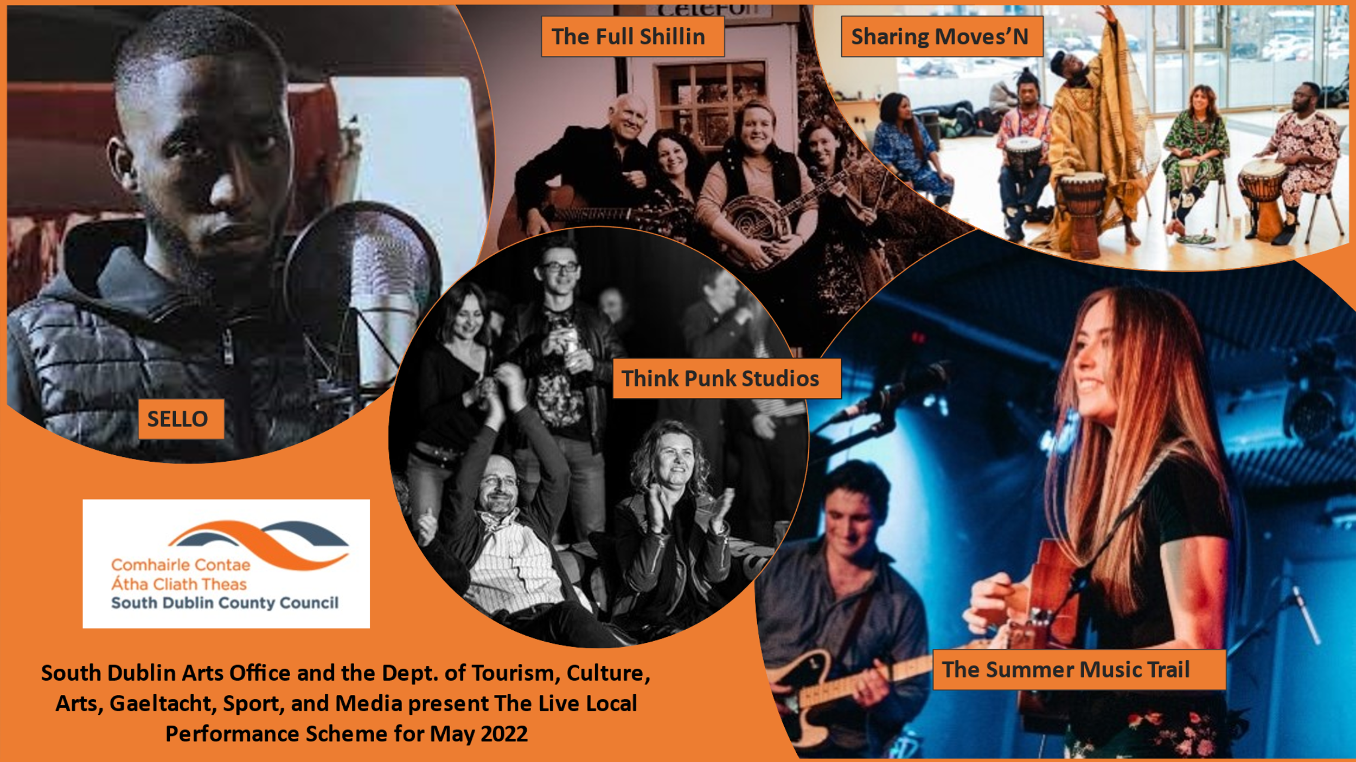

A myriad of events will take place with live music performances supported by South Dublin Arts Office and the Dept. of Tourism, Culture, Arts, Gaeltacht, Sport, and Media through their Live Local Performance Scheme.
With dance and music events for all ages from Trad, Hip Hop, Folk, Funk to Jazz, Afro and Brazilian Beats there’s something for everybody. Showcasing professional and emerging artists from across the area there are events to suit all tastes in South Dublin in May.
Date | Event | Venue | Booking Details | Time
Fri 22nd | The Full Shillin | Lisheen Nursing Home, Rathcoole | Private event - By Invitation only
Fri 29th | The Full Shillin | Lucan Lodge Nursing Home | Private event - By Invitation only
Thur 12th | The Full Shillin | Sally Park Nursing Home, Knocklyon | Private event - By Invitation only
Fri 6th -Fri 13th | Sello | 8 X Primary Schools across South Dublin | Private event - By Invitation only
Sat 7th | Think Punk Studios | Think Punk Studios, JFK | https://takeyourseats.ticketsolve.com/shows/873633402 | 8pm – Tickets €14
Fri 20th | The Full Shillin | Kiltipper Nursing Home, Bohernabreena | Private event - By Invitation only
Fri 13th | Summer Music Trail | N. Clondalkin Library | Private event - By Invitation only | 10-11am & 11.30 - 12.30pm
Fri 20th | Summer Music Trail | Tallaght Library | Private event - By Invitation only | 10-11am & 11.30 - 12.30pm
Sat 21st | Summer Music Trail | East Village, Brú Chrónáin, 15 Tower Road, Clondalkin | Eventbrite | 8pm – Tickets €10
Sat 21st | Think Punk Studios | Think Punk Studios, JFK | https://takeyourseats.ticketsolve.com/shows/873633402 | 8pm – Tickets €15
Fri 27th | Sharing Moves’N - Dance Showcase | Adamstown Community Centre, Adamstown | Eventbrite & https://tallaght-arts.ie/sharing-moves | 4.30 pm – Free Event
Sat 28th | Sharing Moves’N - Dance Showcase | MacUíllíam Estate Tallaght Basketball Court | Eventbrite & https://tallaght-arts.ie/sharing-moves | 4.30 pm – Free Event
Sat 28th | The Snug Sessions | Áras Chrónáin | snugproductions.ie | Doors Open 7.30pm for 8pm Event – Tickets €15

