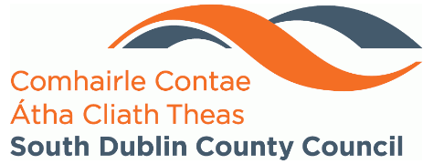

SOUTH DUBLIN COUNTY COUNCIL
Environmental Education Grant 2024

1. Applicant Details

Organisation Name (as per Tax Clearance Certificate or Tax Reference Number):

Project Co-ordinator: Contact Number:

Address:

Email Address:

2. Project Title

3. Project Summary
Please give a brief outline of your project (200-word max)

4. Summary of Project Costs

Please itemise all costs in relation to the delivery of your project. If workshop based, please include the amount and price per workshop.

Cost Item | Amount
 | €
 | €
 | €
 | €
 | €
Total Costs | €

5. Applicant’s Authorisation for Assessment, Audit and Data Retention

- All particulars as entered above, and any supplementary materials supplied in support of this application, are correct as of the date of this signature.
- I acknowledge that my application form will be assessed based on the attached criteria and understand that it may or may not receive a funding allocation.
- I acknowledge that my application form will be held by South Dublin County Council in line with appropriate data retention policies and GDPR.
- To ensure appropriate governance, I acknowledge that my application may be subject to audit.

Signed:____________________ ______ Date:_______________________

This grant is funded by South Dublin County Council. We take our role in Data Protection seriously. Therefore, any personal information you provide will not be shared with any third party.

Your application form will be retained on file (print/electronic) in compliance with the Council’s data retention policy and GDPR.

- Completed application forms should be returned to envawareness@sdublincoco.ie by 5pm on Friday 27th September 2024 at the latest. Submission of applications by email only.

