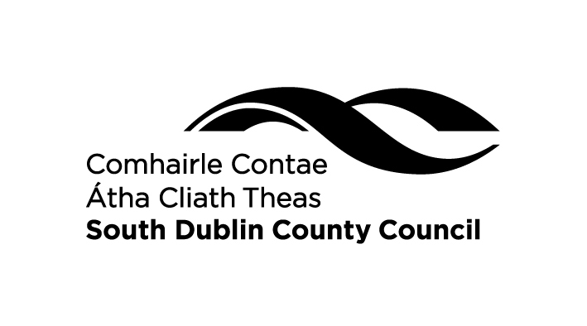
CHRISTMAS DECORATION COMPETITION 2018
Official Entry Form
Reuse household recyclables to make Christmas Decorations...
egg boxes, old CD’s, yogurt tubs, cereal boxes, lollipop sticks, broken toys, old socks, & your imagination!

Win a set of Energy Saving LED Christmas Lights!

Closing date for receipt of entries is
Tuesday 4th December, 2018 by 5 pm.

Please complete the application form

Name ___________________________________________________

Age (please tick) Under 9 Over 9

Address ___________________________________________________

___________________________________________________

Telephone Number ___________________________________________________

Name of Decoration ___________________________________________________
(Not Necessary)

Detailed description of decoration, including all the materials used

Mark your name, age category and school somewhere on the decoration if possible. Submit your Decoration along with this official entry form to Nessa Watkins, Environment Awareness Section, Environment Services, South Dublin County Council, County Hall, Tallaght, Dublin 24. Telephone (01) 4149000.

Any entries not collected by 4th January 2019 will be recycled.

