Claim form – Domestic Lead Remediation Grant Scheme
- Details of the applicant
Name of applicant (in BLOCK):
Address (location of DWWTS):

Eircode:
Daytime telephone No:
E-mail address:
- General description and cost of works carried out (Itemised receipt(s) detailing all costs/works must be provided when the works are completed):
- Details of contractor(s): (print out of e-Tax Clearance for each contractor must be provided)
Contractor 1 | Contractor 2 (if applicable)
Contractor name: | Contractor name:
Contractor address:  Eircode: | Contractor address:  Eircode:
- Irish Water Customer Opt-in Lead Replacement Scheme
- Is the claimant an Irish Water customer? | Yes 󠄀󠄀 No 󠄀󠄀
If yes, has the claimant availed of the Opt-in Lead Replacement Scheme? | Yes 󠄀󠄀 No 󠄀󠄀

DECLARATION

I declare that the information provided by me on this application form are correct and I understand that the provision of any false or misleading information or invalid supporting documents may result in this claim being cancelled.

Signature of claimant:

Date:

CHECK LIST

Please ensure that the following documentation is included with your claim for payment of grant aid:

- Evidence of a requirement to replace lead pipes and related fittings, as detailed in Section 2 of the Terms and Conditions,

- Proof of payment, including original receipts showing itemised list of all work(s) carried out and for any other eligible costs,

- Proof of Tax Clearance status for each contractor engaged, as outlined in Section 6 of the Terms and Conditions.

Please submit the fully completed Form DLRG 1a and supporting documentation to your Local Authority Office at the address below:
Environment, Water & Climate Change
South Dublin County Council
County Hall
Tallaght
D24 A3XC
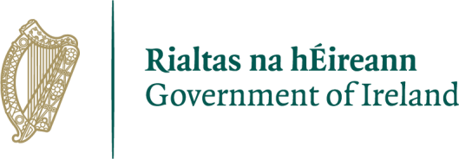
Terms and Conditions Domestic Lead Remediation Grant Scheme from 1 December 2022
1

Prepared by the Department of Housing, Local Government and Heritage

gov.ie/housin
g

Grants payable under the Housing (Domestic Lead Remediation Grant) Regulations 2022 (S.I. No. 519 of 2022)

- Please read the following information notes before completing the application form.

- All questions on the form must be answered and, where specified, supporting documents must be provided. Incomplete forms or those which are not accompanied by the appropriate documents will not be processed by the local authority.

- Before work commences, you must ensure that you have fulfilled all the Terms and Conditions of the Domestic Lead Remediation Grant Scheme, as outlined in this document. Incomplete applications will not be considered and payment may be refused by the local authority.

- If you are an Irish Water Customer, please ensure you have contacted Irish Water in relation to their “Customer Opt-in Lead Pipe Replacement Scheme”, (Further information can be found here: https://www.water.ie/projects/strategic-plans/leadmitigation-plan/.

- The grant scheme is administered by local authorities. All matters relating to the day to-day operation of the grant scheme, including applications and payments, are a matter for the local authority responsible for your area.

- Any enquiries about the Domestic Lead Remediation Grant Scheme should be addressed to the relevant local authority.

2

Purpose of Grant
In order to reduce exposure to lead in drinking water, and in line with the
Government national strategy to reduce exposure to lead in drinking water, the Domestic Lead Remediation Grant Scheme was introduced. The scheme was introduced to assist households with the costs of replacing lead piping or related fittings located within the internal distribution system connected to a domestic water supply that serves a house.
Section 2 of the Water Services Act 2007, as amended, provides that “internal distribution system” means that part of a distribution system, within the curtilage of a premises, which is used for the provision of water for human consumption or food or drinks production.
The scope of the grant and relevant definitions are as detailed in the Housing (Domestic Lead Remediation Grant) Regulations 2022 (S.I. No. 519 of 2022), which shall come into operation on 1st December 2022.

Eligibility
An individual may be eligible to apply for a grant to their local authority, if they meet the criteria set out in these Terms and Conditions.
In order to qualify for the grant, the house concerned must be occupied by the applicant as their normal place of residence. If you are a long-term tenant of the property you must have the permission of the owner to carry out the works.
For the purposes of this grant scheme the property must be a domestic residence and private holiday homes and properties operated on a commercial basis are excluded (e.g. short term holiday lettings, self-catering properties, caravans/mobile homes, caravan/mobile home sites etc.). Properties owned by local authorities, housing associations, Health Services Executive etc. are not eligible.
In advance of applying for a grant, an individual must ensure that they have evidence of a requirement to replace lead pipes and related fittings to include with the application to their relevant local authority. This evidence must be in the form of a:
a) notification from a water supplier advising that there is likely to be lead pipes and related fittings within the internal distribution system of the house concerned,

OR
b) certificate issued within the six months immediately prior to the date of application by a laboratory accredited by the Irish National Accreditation Board, confirming a parametric value for lead in the drinking water supply to the house concerned, which exceeds the statutory limit, currently 10μg/l (10 micrograms per litre),

OR
c) notification from a registered building professional advising that there are lead pipes and related fittings located within the internal distribution system of the house concerned.

Level of Grant
The level of the grant shall be based on the approved costs in relation to the replacement of lead pipes and related fittings. The means test is no longer required. The approved cost shall not exceed the following limits:
- The level of grant aid available is determined on the basis of 100% of the approved cost of the works, subject to a maximum of €5,000.
- The minimum expenditure, on eligible works, required to process the application is €750.

Approved Cost
For the purposes of this scheme, in relation to the replacement of lead pipes or related fittings, the approved cost means the cost estimated by the local authority to be the reasonable cost of carrying out the replacement works or the actual cost of carrying out the works, whichever is the lesser.
The cost associated with the actual provision of either a certificate outlined at 2(b) or a notification at 2(c), under “Eligibility” above, are eligible costs for the purposes of the grant, to a maximum amount of €200. This cost is to be included in the calculation of the maximum eligible cost total of €5,000. Note any indirect costs incurred by the applicant themselves are not eligible costs.

Receipts and Certification
Each claim for a grant must be accompanied by an original receipt for the total amount paid from each contractor engaged for the purpose of the remediation works. The receipt provided must include an itemised list of the works carried out and the associated costs for each item.
It is the responsibility of the applicant to satisfy themselves that any contractor engaged is competent to carry out the works required and that suitable materials are used. Each claim must also include certification from the contractor engaged to carry out the works that any materials used, including pipes and fittings, are of appropriate quality and that a proper standard of workmanship has been applied in the course of the works.

Tax Clearance Requirements
In order for eligible receipts to be reimbursed to the applicant by the local authority, the tax clearance status of the contractor must be up to date. In the case of each contractor engaged to carry out a site assessment (if required), repairs, upgrading or replacement, the applicant should furnish, to the housing authority with their application form, an up to date Revenue On-Line Service (ROS) printout of an eTax
Clearance certificate provided by the contractor or both the Tax Clearance Access Number (TCAN) and Tax Reference Number issued to the contractor by the Revenue Commissioners.
Where the tax clearance status of the contractor cannot be established, which confirms that the tax affairs of the contractor are fully up to date at the time the grant application is being assessed, then the local authority should refuse the application for grant assistance.

Processing of Claims for Grant
The scheme will continue to be administered by the local authorities on behalf of the Department of Housing, Local Government and Heritage. The following procedure shall apply to the processing of all grants under the Housing (Domestic Lead Remediation Grant) Regulations 2022.
- Claims for payment should be submitted to the local authority in whose functional area the house, the subject of the application, is located.
- Claims must be submitted on the DLRG 1a form available from the appropriate local authority.
- If assistance with completing the form is required, please contact the relevant local authority.
- The relevant local authority will subsequently advise the applicant in writing (or via email) if the application is deemed eligible (subject to terms and conditions) or ineligible.
- Once all required documentation, as detailed in these Terms and Conditions, have been received and verified, the local authority will endeavour to process the claim as quickly as possible.
- The local authority reserves the right to make any enquiries it considers necessary, to verify information or supporting documents provided as part of a claim for grant aid, and may exclude from consideration for grant aid any applicant who supplies false or misleading information or documents.

Appeals Process
In processing applications under this grant scheme, it is recognised that some applicants may be dissatisfied with the decision of the local authority. Every applicant will have a right to an appeals process.
The following procedure shall apply to each appeal:
- Applicants are invited to submit a written appeal (this may be via email) on any decision notified to them by the local authority on their application, within three weeks of the date of the decision.
- The appeal must state the reasons for the appeal and the grounds for same.
- Appeals will be considered and adjudicated on by a local authority official who was not involved with the original decision, as designated by the Director of Services of the relevant Section. This process will be completed within four weeks of receipt.
- The outcome of the appeal will be notified in writing to the appellant within two weeks of the decision being made.

gov.ie/housing

1

Department of Housing, Local Government and H
eritage

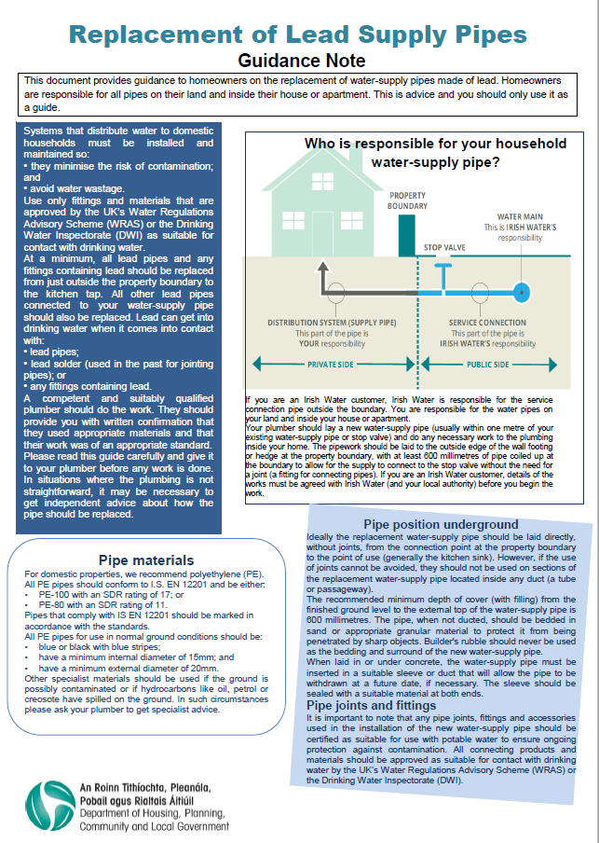
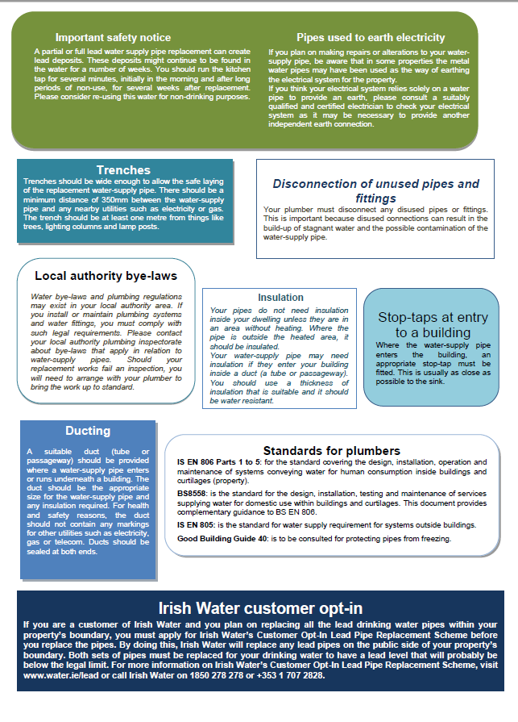
South Dublin County Council
County Hall,
Tallaght,
Dublin 24

Privacy Statement for Environment, Water & Climate Change Department
Business Unit: Water Services
Who we are and why do we require your information?
South Dublin County Council seeks to promote the economic, social and cultural development of the County and in doing so contribute significantly to improving the quality of life of the people of South Dublin County.
The delivery of high-quality services, tailored to meet the needs of all our customers, remains one of South Dublin County Council’s core objectives and is included in our Corporate Plan. This quality service includes not only the level and quality of service given to our customers but also the quality of our decision-making processes, the efficiency and effectiveness of our corporate operations, standard of our facilities and our ability to adapt in an ever-changing environment.
To provide the most effective and targeted range of services to meet the needs of the citizens, communities and businesses of South Dublin County we will be required to collect, process and use certain types of information about people and organisations. Depending on the service being sought or provided the information sought may include ‘personal data’ as defined by the Data Protection Acts and by the General Data Protection Regulation (GDPR) and may relate to current, past and future service users; past, current and prospective employees; suppliers; and members of the public who may engage in communications with our staff. In addition, staff may be required, from time to time, to collect, process and use certain types of personal data to comply with regulatory or legislative requirements.

Why does the Council have a privacy statement?
South Dublin County Council has created this privacy statement to demonstrate the Council’s firm commitment to privacy and the security of the personal data you provide to the Council.
South Dublin County Council’s commitment to you is that the personal data you may be required to supply to us is;
- Obtained lawfully, fairly and in a transparent manner.
- Obtained and retained for only specified, explicit and legitimate purposes.
- Adequate, relevant and limited to what is necessary for the purpose for which it was obtained
- Recorded accurately and, where necessary, updated.
- Stored safely and securely.
- Kept only for as long as is necessary for the purposes for which it was obtained.
- Kept in a form which permits identification of the data subject.
- Processed fairly and in a manner that ensures the appropriate security of the personal data including protection against unauthorised or unlawful processing.

Service referred to in this Privacy Statement:
Domestic Lead Remediation Grant
Personal data required:
Property address & name/names of applicant/applicants.

Specific and legitimate purpose for which the personal data is being sought:
Processing applications for financial assistance relating to Domestic Lead Remediation Grant
Legal basis under which the information is required to be supplied:
Domestic Lead Remediation (Financial Assistance) Regulations 2022 (S.I. No. 519 of 2022).
Other organisations/bodies/entities that the Council will be required to share data with, or obtain data from, in order to provide the required service
Department of Housing, Local Government and Heritage
How your personal data will be kept safe from unauthorised or unlawful processing
We take our data security responsibilities seriously, employing the most appropriate physical and technical measures, including staff training and awareness. We review our data security measures and procedures regularly.
Period for which your personal data will be retained:
The Environment, Water & Climate Change Directorate will only keep your personal data for as long as is necessary for the purpose for which we are processing it and in accordance with our Record Management & Retention policy unless we have a legitimate reason for keeping it, for example, any legal requirement to keep the data for a set time period. Where we do not need to continue to process your personal data, it will be securely destroyed.

Contact Details
In order to communicate with you, the Council will ask for your contact details. You do not have to provide all contact details but providing more, such as email, phone, address, makes it easier for the Council to communicate with you.

Your Data Protection Rights
You have the right to request access to personal data held about you, obtain confirmation as to whether data concerning you exists, be informed of the content and source of data and check its accuracy. In addition, if the data held by South Dublin County Council is found to be inaccurate, you have the right to have the data corrected by the Council.
You may request to have information erased, object to direct marketing and to restrict the processing of your information, including automated decision-making.
You have the right to request data portability (transfer) of personal data held electronically by the Council to another data controller where technically feasible.
You may withdraw consent at any time where processing is based entirely on your consent.
Please note that to help protect your privacy the Council will take steps to verify your identity before granting access to personal data.
Data access requests should be made in writing and addressed to the Data Protection Officer, South Dublin County Council, County Hall, Tallaght, Dublin 24.
E-Mail: dataprotection@sdublincoco.ie.
Telephone: 01-4149000.

Right of Complaint to the Data Protection Commission
If you are not satisfied with the outcome of the response you receive in relation to a data access request or are unhappy with the manner of the processing of your data by South Dublin County Council then you are entitled to make a complaint to the Data Protection Commission which may investigate the matter for you.
The Data Protection Commission’s website is www.dataprotection.ie or you can contact the Commission’s Office at:
Phone: 0761104800 or 0578684800
E-mail: info@dataprotection.ie
Postal Address: Data Protection Commission
21 Fitzwilliam Square South
Dublin 2 D02 RD28

